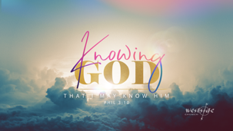
12-24-20
Candlelight Services

The Light of the World

REALLY BIG ANNOUNCEMENT !!

Angels

“Glory to God in the highest and on earth,
peace, goodwill toward men!”
-Luke 2:14

Shepherds

Luke 2:16-17
They hurried to the village and found Mary and Joseph. And there was the baby, lying in the manger. ¹⁷ After seeing him, the shepherds told everyone what had happened and what the angel had said to them about this child.

Wise Men

Matthew 2:2 Saying, Where is he that is born King of the Jews? for we have seen his star in the east, and are come to worship him.

Questions:

Who is . . . Jesus Christ ?

Colossians 1:15-23
Christ is the visible image of the invisible God. He existed before anything was created and is supreme over all creation, ¹⁶ for through him God created everything in the heavenly realms and on earth. He made the things we can see and the things we can’t see— such as thrones, kingdoms, rulers, and authorities in the unseen world. Everything was created through him and for him. ¹⁷ He existed before anything else, and he holds all creation together.

What Is Your Response?

John 3:16 (KJV)
For God so loved the world, that he gave his only begotten Son, that whosoever believeth in him should not perish, but have everlasting life.

begin lighting candles . . .

O Come All Ye Faithful: song

Dismissal:

Matthew 5:14–16
“You are the light of the world—like a city on a hilltop that cannot be hidden. ¹⁵ No one lights a lamp and then puts it under a basket. Instead, a lamp is placed on a stand, where it gives light to everyone in the house. ¹⁶ In the same way, let your good deeds shine out for all to see, so that everyone will praise your heavenly Father.

