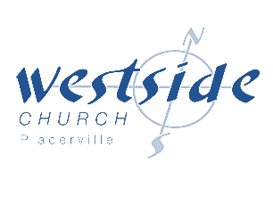
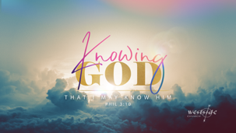
12-20-20

Good Government

What the Bible says:

1. Good Government ultimately comes from Jesus.

Isaiah 9:6–7 (NKJV)
⁶ For unto us a Child is born,
Unto us a Son is given;
And the government will be upon His shoulder.
And His name will be called
Wonderful, Counselor, Mighty God,
Everlasting Father, Prince of Peace.
⁷ Of the increase of His government and peace
There will be no end,
Upon the throne of David and over His kingdom,
To order it and establish it with judgment and justice
From that time forward, even forever.
The zeal of the Lord of hosts will perform this.

GOVERNMENT: rule, dominion

Good Government is like river banks.

2. Good government begins with “self-government” . . . it begins with me.

Micah 6:8
“O people, the Lord has told you what is good,
and this is what he requires of you:
to do what is right, to love mercy,
and to walk humbly with your God.”

Also: in the family:
- Children are most healthy and secure when there is good government in the home.

3. Good Government is necessary in the church.

Jesus is the head of the church.

Colossians 1:15–18
¹⁵ Christ is the visible image of the invisible God.
He existed before anything was created and is supreme over all creation,
¹⁶ for through him God created everything
in the heavenly realms and on earth.
He made the things we can see
and the things we can’t see—
such as thrones, kingdoms, rulers, and authorities in the unseen world.
Everything was created through him and for him.
¹⁷ He existed before anything else,
and he holds all creation together.
¹⁸ Christ is also the head of the church,
which is his body.

1 Peter 5:1–4 (ESV)
So I exhort the elders among you, as a fellow elder and a witness of the sufferings of Christ, as well as a partaker in the glory that is going to be revealed: ² shepherd the flock of God that is among you, exercising oversight, not under compulsion, but willingly, as God would have you; not for shameful gain, but eagerly; ³ not domineering over those in your charge, but being examples to the flock. ⁴ And when the chief Shepherd appears, you will receive the unfading crown of glory.

4. Good Government is necessary in our nation.

"It is impossible to govern the world
without God and the Bible"
-George Washington

“ Our Constitution was made only for a moral and religious people. It is wholly inadequate to the government of any other.”
-John Adams

“We have staked the future of all of our political institutions upon the capacity of each and all of us to govern ourselves, to control ourselves, to sustain ourselves according to the Ten Commandments of God.”
-James Madison

"The highest glory of the American Revolution was this; it connected in one indissoluble bond the principles of civil government with the principles of Christianity.”
-John Quincy Adams

Psalm 11:3 (ESV)
If the foundations are destroyed,
what can the righteous do?”

Response:

His Kingdom will last FOREVER !!!

Of the increase of His government and peace
There will be no end. Upon the throne of David and over His kingdom
To order it and establish it with judgment and justice
From that time forward, even forever.

What is God speaking to me?

Specifically, how will I obey Him?

