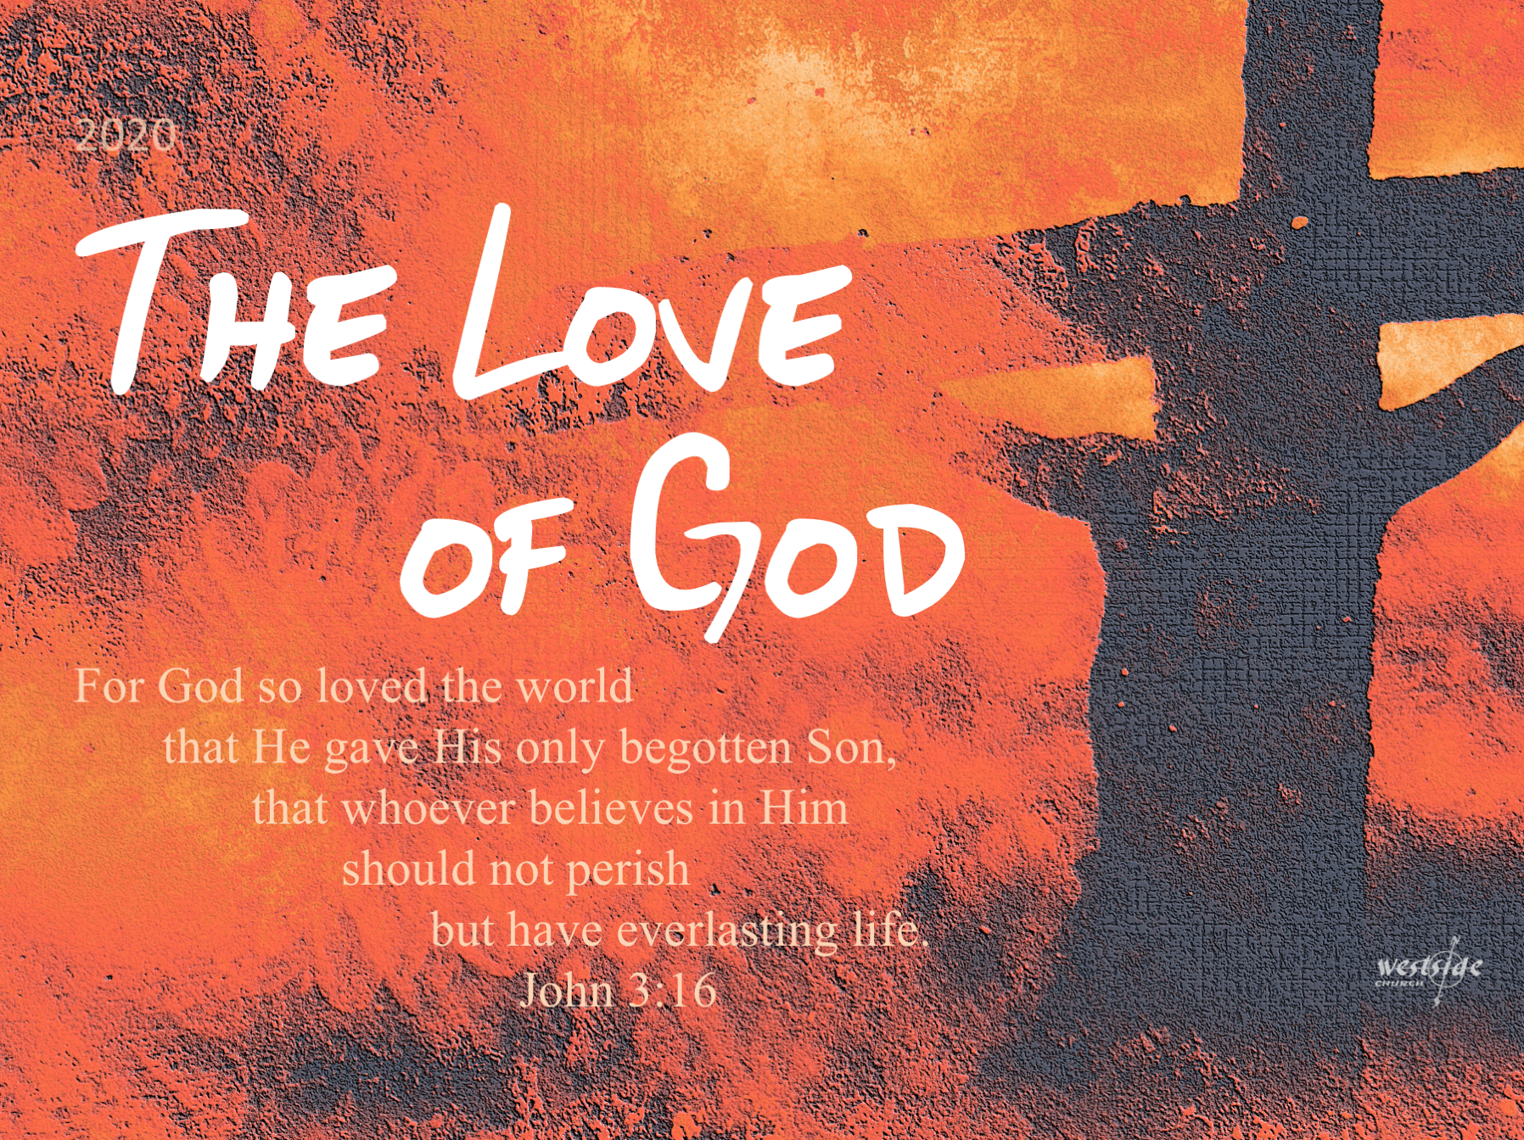
4-5-20
1st John #14

A Child Of God

What The Bible Says:

1 John 5:1-10
Everyone who believes that Jesus is the Christ has become a child of God. And everyone who loves the Father loves his children, too. ² We know we love God’s children if we love God and obey his commandments. ³ Loving God means keeping his commandments, and his commandments are not burdensome. ⁴ For every child of God defeats this evil world, and we achieve this victory through our faith. ⁵ And who can win this battle against the world? Only those who believe that Jesus is the Son of God.

⁶ And Jesus Christ was revealed as God’s Son by his baptism in water and by shedding his blood on the cross—not by water only, but by water and blood. And the Spirit, who is truth, confirms it with his testimony. ⁷ So we have these three witnesses— ⁸ the Spirit, the water, and the blood—and all three agree. ⁹ Since we believe human testimony, surely we can believe the greater testimony that comes from God. And God has testified about his Son. ¹⁰ All who believe in the Son of God know in their hearts that this testimony is true. Those who don’t believe this are actually calling God a liar because they don’t believe what God has testified about his Son.
A Closer Look:

1. God gives the world a huge ________________________.

1 John 5:1a
Everyone who believes that Jesus is the Christ has become a child of God.

John 3:16 (ESV)
“For God so loved the world, that he gave his only Son, that whoever believes in him should not perish but have eternal life.

2. This is the Great Commandment in _______________.

1 John 5:1b
And everyone who loves the Father loves his children, too.

Mark 12:29-31
Jesus replied, “The most important commandment is this: ‘Listen, O Israel! The LORD our God is the one and only LORD. ³⁰ And you must love the LORD your God with all your heart, all your soul, all your mind, and all your strength.’ ³¹ The second is equally important: ‘Love your neighbor as yourself.’ No other commandment is greater than these.”

Why does the Great Commandment come in two parts?

“A person cannot separate their love for God
and their love for others. Our love for God (which is invisible to others) is demonstrated by our love for others.”
-sb

3. Loving God means keeping His ___________________

1 John 5:2-3 (MSG)
The reality test on whether or not we love God's children is this: Do we love God? Do we keep his commands? ³ The proof that we love God comes when we keep his commandments and they are not at all troublesome.

4. It’s always a walk of _________________.

- foundational belief and value

- faith - hope - love 1 Cor 13

- Hebrews 6: elementary foundations of our faith . . .

Hebrews 6:1-3
So let us stop going over the basic teachings about Christ again and again. Let us go on instead and become mature in our understanding. Surely we don’t need to start again with the fundamental importance of repenting from evil deeds and placing our faith in God. ² You don’t need further instruction about baptisms, the laying on of hands, the resurrection of the dead, and eternal judgment. ³ And so, God willing, we will move forward to further understanding.

Fear is faith in the negative . . .

Fear is believing in (and acting on) satan’s word

Faith is believing in (and acting on) God’s Word

Finally:

5. Who wins in this battle?

1 John 5:5
And who can win this battle against the world? Only those who believe that Jesus is the Son of God.

- the world is not PEOPLE

- the world is SYSTEMS and the devil’s INFLUENCE

The Good News . . .

Response:

What is God speaking to me?

Specifically, how will I obey Him?

