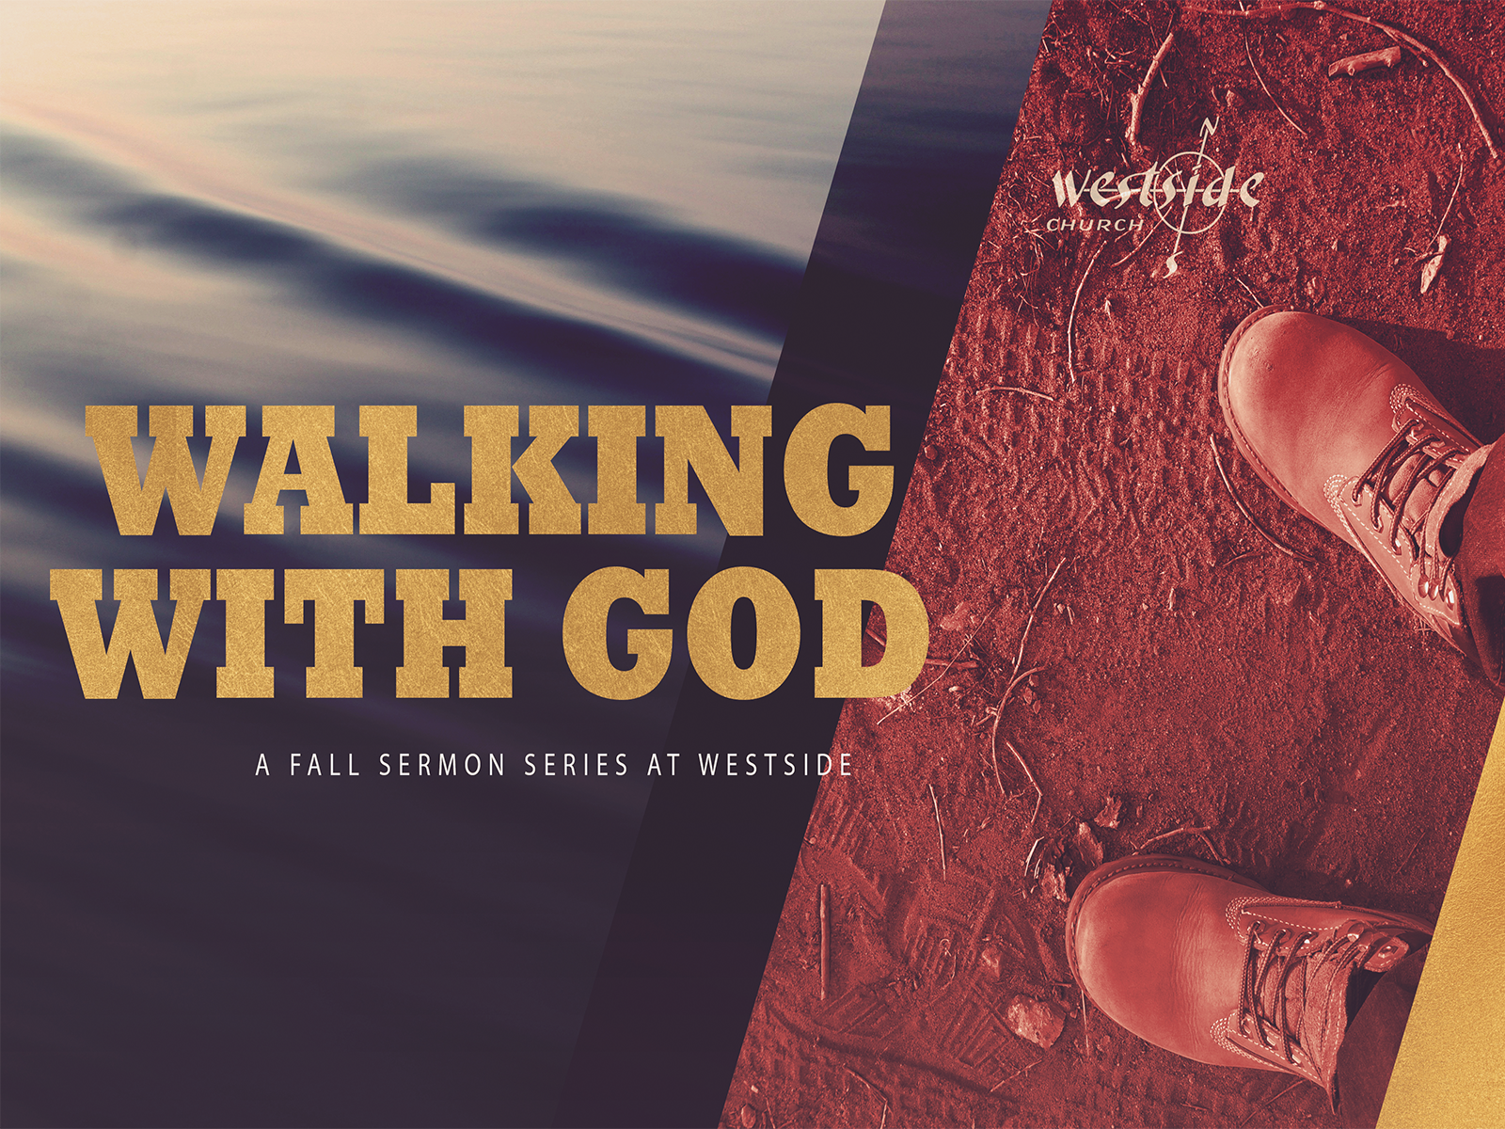
November 10, 2019
Walking With God #9

Walking with God
Service

- Why should we serve?

  - Jesus ________________ it to us

Matthew 20:25-28 (ESV)
²⁵ But Jesus called them to him and said, “You know that the rulers of the Gentiles lord it over them, and their great ones exercise authority over them. ²⁶ It shall not be so among you. But whoever would be great among you must be your servant, ²⁷ and whoever would be first among you must be your slave, ²⁸ even as the Son of Man came not to be served but to serve, and to give his life as a ransom for many.”

  - It is not good for man to be alone

Genesis 2:15-18 (ESV)
¹⁵ The LORD God took the man and put him in the garden of Eden to work it and keep it. ¹⁶ And the LORD God commanded the man, saying, “You may surely eat of every tree of the garden, ¹⁷ but of the tree of the knowledge of good and evil you shall not eat, for in the day that you eat of it you shall surely die.” ¹⁸ Then the LORD God said, “It is not good that the man should be alone; I will make him a helper fit for him.”

  - A body works best when it is _____________

1 Corinthians 12:14-20 (ESV)
¹⁴ For the body does not consist of one member but of many. ¹⁵ If the foot should say, “Because I am not a hand, I do not belong to the body,” that would not make it any less a part of the body. ¹⁶ And if the ear should say, “Because I am not an eye, I do not belong to the body,” that would not make it any less a part of the body. ¹⁷ If the whole body were an eye, where would be the sense of hearing? If the whole body were an ear, where would be the sense of smell? ¹⁸ But as it is, God arranged the members in the body, each one of them, as he chose. ¹⁹ If all were a single member, where would the body be? ²⁰ As it is, there are many parts, yet one body.

- Who should be serving?

  - _________________

1 Peter 2:9-10 (ESV)
⁹ But you are a chosen race, a royal priesthood, a holy nation, a people for his own possession, that you may proclaim the excellencies of him who called you out of darkness into his marvelous light. ¹⁰ Once you were not a people, but now you are God’s people; once you had not received mercy, but now you have received mercy.

  - In the area God has ______________ you into

1 Corinthians 12:4-7 (ESV)
⁴ Now there are varieties of gifts, but the same Spirit; ⁵ and there are varieties of service, but the same Lord; ⁶ and there are varieties of activities, but it is the same God who empowers them all in everyone. ⁷ To each is given the manifestation of the Spirit for the common good.

  - Knowing ______________ it is you serve

Colossians 3:23-24 (ESV)
²³ Whatever you do, work heartily, as for the Lord and not for men, ²⁴ knowing that from the Lord you will receive the inheritance as your reward. You are serving the Lord Christ.

- How do we serve with joy?
  - Make sure you have the _____ for what you are doing.

Romans 12:4-8 (ESV)
⁴ For as in one body we have many members, and the members do not all have the same function, ⁵ so we, though many, are one body in Christ, and individually members one of another. ⁶ Having gifts that differ according to the grace given to us, let us use them: if prophecy, in proportion to our faith; ⁷ if service, in our serving; the one who teaches, in his teaching; ⁸ the one who exhorts, in his exhortation; the one who contributes, in generosity; the one who leads, with zeal; the one who does acts of mercy, with cheerfulness.

  - Realize you ______________ do everything
  - Get _________________

Matthew 11:28-30 (ESV)
²⁸ Come to me, all who labor and are heavy laden, and I will give you rest. ²⁹ Take my yoke upon you, and learn from me, for I am gentle and lowly in heart, and you will find rest for your souls. ³⁰ For my yoke is easy, and my burden is light.”
  - Stay focused on the ________ we are doing all of this

Matthew 28:18-20 (ESV)
¹⁸ And Jesus came and said to them, “All authority in heaven and on earth has been given to me. ¹⁹ Go therefore and make disciples of all nations, baptizing them in the name of the Father and of the Son and of the Holy Spirit, ²⁰ teaching them to observe all that I have commanded you. And behold, I am with you always, to the end of the age.”

Response:

What is God speaking to me?

Specifically, how will I obey Him?

