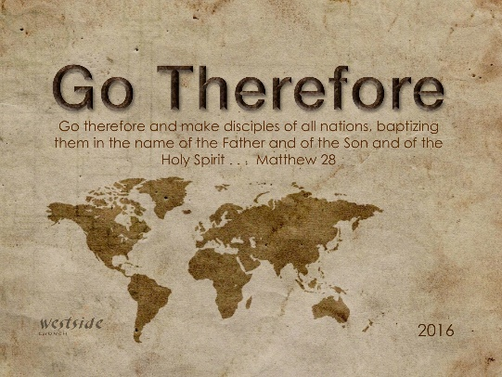
11-20-16

Romans #12

Abraham Never Waivered

What The Bible Says

Romans 4:1-25
Abraham was, humanly speaking, the founder of our Jewish nation. What did he discover about being made right with God? ² If his good deeds had made him acceptable to God, he would have had something to boast about. But that was not God’s way. ³ For the Scriptures tell us, “Abraham believed God, and God counted him as righteous because of his faith.” ⁴ When people work, their wages are not a gift, but something they have earned. ⁵ But people are counted as righteous, not because of their work, but because of their faith in God who forgives sinners. ⁶ David also spoke of this when he described the happiness of those who are declared righteous without working for it: ⁷ “Oh, what joy for those whose disobedience is forgiven, whose sins are put out of sight. ⁸ Yes, what joy for those whose record the LORD has cleared of sin.” ⁹ Now, is this blessing only for the Jews, or is it also for uncircumcised Gentiles? Well, we have been saying that Abraham was counted as righteous by God because of his faith. ¹⁰ But how did this happen? Was he counted as righteous only after he was circumcised, or was it before he was circumcised? Clearly, God accepted Abraham before he was circumcised! ¹¹ Circumcision was a sign that Abraham already had faith and that God had already accepted him and declared him to be righteous—even before he was circumcised. So Abraham is the spiritual father of those who have faith but have not been circumcised. They are counted as righteous because of their faith. ¹² And Abraham is also the spiritual father of those who have been circumcised, but only if they have the same kind of faith Abraham had before he was circumcised. ¹³ Clearly, God’s promise to give the whole earth to Abraham and his descendants was based not on his obedience to God’s law, but on a right relationship with God that comes by faith. ¹⁴ If God’s promise is only for those who obey the law, then faith is not necessary and the promise is pointless. ¹⁵ For the law always brings punishment on those who try to obey it. (The only way to avoid breaking the law is to have no law to break!) ¹⁶ So the promise is received by faith. It is given as a free gift. And we are all certain to receive it, whether or not we live according to the law of Moses, if we have faith like Abraham’s. For Abraham is the father of all who believe. ¹⁷ That is what the Scriptures mean when God told him, “I have made you the father of many nations.” This happened because Abraham believed in the God who brings the dead back to life and who creates new things out of nothing. ¹⁸ Even when there was no reason for hope, Abraham kept hoping—believing that he would become the father of many nations. For God had said to him, “That’s how many descendants you will have!” ¹⁹ And Abraham’s faith did not weaken, even though, at about 100 years of age, he figured his body was as good as dead—and so was Sarah’s womb. ²⁰ Abraham never wavered in believing God’s promise. In fact, his faith grew stronger, and in this he brought glory to God. ²¹ He was fully convinced that God is able to do whatever he promises. ²² And because of Abraham’s faith, God counted him as righteous. ²³ And when God counted him as righteous, it wasn’t just for Abraham’s benefit. It was recorded ²⁴ for our benefit, too, assuring us that God will also count us as righteous if we believe in him, the one who raised Jesus our Lord from the dead. ²⁵ He was handed over to die because of our sins, and he was raised to life to make us right with God.

Philippians 3:7-14
I once thought these things were valuable, but now I consider them worthless because of what Christ has done. (The Gospel) ⁸ Yes, everything else is worthless when compared with the infinite value of knowing Christ Jesus my Lord. For his sake I have discarded everything else, counting it all as garbage, so that I could gain Christ ⁹ and become one with him. I no longer count on my own righteousness through obeying the law; rather, I become righteous through faith in Christ. For God’s way of making us right with himself depends on faith. ¹⁰ I want to know Christ and experience the mighty power that raised him from the dead . . . ¹² I don’t mean to say that I have already achieved these things or that I have already reached perfection. But I press on to possess that perfection for which Christ Jesus first possessed me. ¹³ No, dear brothers and sisters, I have not achieved it, but I focus on this one thing: Forgetting the past and looking forward to what lies ahead, ¹⁴ I press on to reach the end of the race and receive the heavenly prize for which God, through Christ Jesus, is calling us.

1. Focus On _______________ Thing

Ephesians 5:15-16 (ESV)
¹⁵ Look carefully then how you walk, not as unwise but as wise, ¹⁶ making the best use of the time, because the days are evil.

1 Timothy 6:17-19 (NLT)
¹⁷ Teach those who are rich in this world not to be proud and not to trust in their money, which is so unreliable. Their trust should be in God, who richly gives us all we need for our enjoyment. ¹⁸ Tell them to use their money to do good. They should be rich in good works and generous to those in need, always being ready to share with others. ¹⁹ By doing this they will be storing up their treasure as a good foundation for the future so that they may experience true life.

Revelation 3:14-19
“Write this letter to the angel of the church in Laodicea. This is the message from the one who is the Amen—the faithful and true witness, the beginning of God’s new creation: ¹⁵ “I know all the things you do, that you are neither hot nor cold. I wish that you were one or the other! ¹⁶ But since you are like lukewarm water, neither hot nor cold, I will spit you out of my mouth! ¹⁷ You say, ‘I am rich. I have everything I want. I don’t need a thing!’ And you don’t realize that you are wretched and miserable and poor and blind and naked.

2. Don’t Look _____________

3. ______________ Looking Forward

How do I keep looking forward?

A. I _____________ _________

1 Timothy 6:20-21
Timothy, guard what God has entrusted to you. Avoid godless, foolish discussions with those who oppose you with their so-called knowledge. ²¹ Some people have wandered from the faith by following such foolishness . . .

B. To Reach ________ ________

Galatians 6:7-10
Don’t be misled—you cannot mock the justice of God. You will always harvest what you plant. ⁸ Those who live only to satisfy their own sinful nature will harvest decay and death from that sinful nature. But those who live to please the Spirit will harvest everlasting life from the Spirit. ⁹ So let’s not get tired of doing what is good. At just the right time we will reap a harvest of blessing if we don’t give up. ¹⁰ Therefore, whenever we have the opportunity, we should do good to everyone—especially to those in the family of faith.

1 Corinthians 9:24-26
Don’t you realize that in a race everyone runs, but only one person gets the prize? So run to win! ²⁵ All athletes are disciplined in their training. They do it to win a prize that will fade away, but we do it for an eternal prize. ²⁶ So I run with purpose in every step.

Response:

What is God speaking to me?

Specifically, how will I obey Him?

