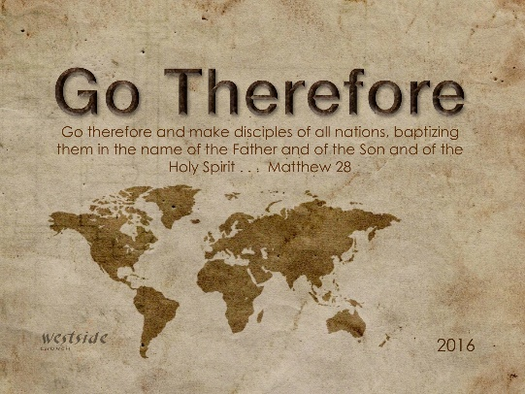
10-30-16
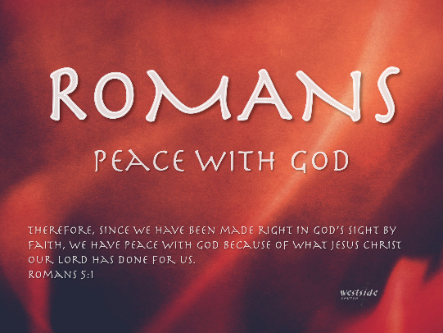

Romans #9

TITLE

Romans 3:1-8 (NLT)
¹ Then what’s the advantage of being a Jew? Is there any value in the ceremony of circumcision? ² Yes, there are great benefits! First of all, the Jews were entrusted with the whole revelation of God. ³ True, some of them were unfaithful; but just because they were unfaithful, does that mean God will be unfaithful?
⁴ Of course not! Even if everyone else is a liar, God is true. As the Scriptures say about him, “You will be proved right in what you say, and you will win your case in court.” ⁵ “But,” some might say, “our sinfulness serves a good purpose, for it helps people see how righteous God is. Isn’t it unfair, then, for him to punish us?” (This is merely a human point of view.) ⁶ Of course not! If God were not entirely fair, how would he be qualified to judge the world?
⁷ “But,” someone might still argue, “how can God condemn me as a sinner if my dishonesty highlights his truthfulness and brings him more glory?”
⁸ And some people even slander us by claiming that we say, “The more we sin, the better it is!” Those who say such things deserve to be condemned.

- Is there any value in being a Jew, or in the ceremony of circumcision?

  - Of course.

  - Entrusted with the whole revelation of God
- Some are unfaithful, but does that mean that God will be unfaithful?

  - God is faithful and true no matter what.

- If our sinfulness shows God’s righteousness, isn’t it unfair for him to punish us? (3:5-8)

  - God is the only fair judge.

Romans 3:9-10 (NLT)
⁹ Well then, should we conclude that we Jews are better than others? No, not at all, for we have already shown that all people, whether Jews or Gentiles, are under the power of sin. ¹⁰ As the Scriptures say, “No one is righteous— not even one.

We are all under the power of sin.

Psalm 51:1-7 (NLT)
¹
Have mercy on me, O God, because of your unfailing love. Because of your great compassion, blot out the stain of my sins. ² Wash me clean from my guilt. Purify me from my sin. ³ For I recognize my rebellion; it haunts me day and night.
⁴ Against you, and you alone, have I sinned; I have done what is evil in your sight. You will be proved right in what you say, and your judgment against me is just.
⁵ For I was born a sinner— yes, from the moment my mother conceived me.
⁶ But you desire honesty from the womb, teaching me wisdom even there.
⁷ Purify me from my sins, and I will be clean; wash me, and I will be whiter than snow.

Here is the good news.

Romans 3:21-22 (NLT)
²¹ But now God has shown us a way to be made right with him without keeping the requirements of the law, as was promised in the writings of Moses and the prophets long ago. ²² We are made right with God by placing our faith in Jesus Christ. And this is true for everyone who believes, no matter who we are.

Application

How does this apply to us as Christians?

- We benefit from the Word of God.

- We have an advantage of learning who God is and living a life worthy of his calling.

- Don’t flaunt it

Response:

What is God saying to me?

Specifically, how will I obey Him?

