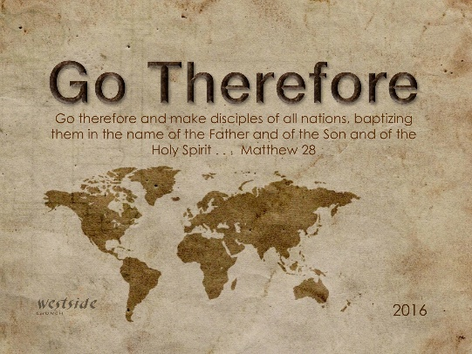
10-9-16
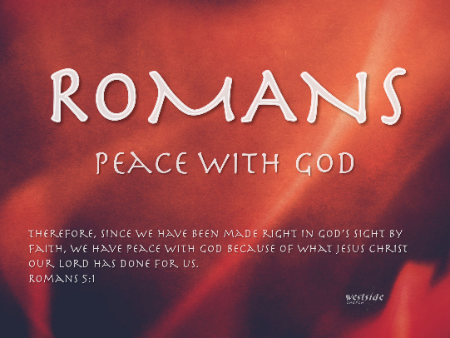

Romans #7

Don’t Just Listen: Do

What The Bible Says

Romans 2:11-16
. . . God does not show favoritism. ¹² When the Gentiles sin, they will be destroyed, even though they never had God’s written law. And the Jews, who do have God’s law, will be judged by that law when they fail to obey it. ¹³ For merely listening to the law doesn’t make us right with God. It is obeying the law that makes us right in his sight. ¹⁴ Even Gentiles, who do not have God’s written law, show that they know his law when they instinctively obey it, even without having heard it. ¹⁵ They demonstrate that God’s law is written in their hearts, for their own conscience and thoughts either accuse them or tell them they are doing right. ¹⁶ And this is the message I proclaim—that the day is coming when God, through Christ Jesus, will judge everyone’s secret life.

1. Faith Without ________________ Is Dead

James 2:14-17 (ESV)
¹⁴ What good is it, my brothers, if someone says he has faith but does not have works? Can that faith save him? ¹⁵ If a brother or sister is poorly clothed and lacking in daily food, ¹⁶ and one of you says to them, “Go in peace, be warmed and filled,” without giving them the things needed for the body, what good is that? ¹⁷ So also faith by itself, if it does not have works, is dead.

It is the very nature of authentic faith
to express itself in good works.

Joshua 1:8
This Book of the Law shall not depart from your mouth, but you shall meditate on it day and night, so that you may be careful to do according to all that is written in it. For then you will make your way prosperous, and then you will have good success.

2. Seriously: Faith Without Works Is ____________

James 2:18-25 (ESV)
But someone will say, “You have faith and I have works.” Show me your faith apart from your works, and I will show you my faith by my works. ¹⁹ You believe that God is one; you do well. Even the demons believe—and shudder! ²⁰ Do you want to be shown, you foolish person, that faith apart from works is useless? ²¹ Was not Abraham our father justified by works when he offered up his son Isaac on the altar? ²² You see that faith was active along with his works, and faith was completed by his works; ²³ and the Scripture was fulfilled that says, “Abraham believed God, and it was counted to him as righteousness”—and he was called a friend of God. ²⁴ You see that a person is justified by works and not by faith alone. ²⁵ And in the same way was not also Rahab the prostitute justified by works when she received the messengers and sent them out by another way?

A. Good works __________________a person’s faith.

^{22-a} You see that faith was active along with his works . . .

“Faith walks together – hand in hand – with good works”

B. Good works will _______________________ a person’s faith.

^{22-b} . . . and faith was completed by his works;

Ephesians 2:8-10 (ESV)
For by grace you have been saved through faith. And this is not your own doing; it is the gift of God, ⁹ not a result of works, so that no one may boast. ¹⁰ For we are his workmanship, created in Christ Jesus for good works, which God prepared beforehand, that we should walk in them.

C. Good works need to be _____________

1 Timothy 4:14-15 (ESV)
Do not neglect the gift you have, which was given you by prophecy when the council of elders laid their hands on you. ¹⁵ Practice these things, immerse yourself in them, so that all may see your progress.

D. Good works must point people to _________ . . . by giving Him the glory.

Matthew 5:16 (ESV)
In the same way, let your light shine before others, so that they may see your good works and give glory to your Father who is in heaven.

John 6:29
Jesus told them, “This is the only work God wants from you: Believe in the one he has sent.”

Application

3. No, Really: ______________ Without Works Is Dead

James 2:26 (ESV)
For as the body apart from the spirit is dead, so also faith apart from works is dead.

“Genuine faith is a reality on which you stake your life, not merely a passive acceptance to a doctrine.”
-sb

Matthew 7:17-20
A good tree produces good fruit, and a bad tree produces bad fruit. ¹⁸ A good tree can’t produce bad fruit, and a bad tree can’t produce good fruit. ¹⁹ So every tree that does not produce good fruit is chopped down and thrown into the fire. ²⁰ Yes, just as you can identify a tree by its fruit, so you can identify people by their actions.
Mark 7:6
Jesus replied, “You hypocrites! Isaiah was right when he prophesied about you, for he wrote, ‘These people honor me with their lips, but their hearts are far from me.
Titus 1:16 (NIV)
They claim to know God, but by their actions they deny him.

Matthew 7:20
Yes, just as you can identify a tree by its fruit, so you can identify people by their actions.
“If we create and then follow a list of rules in order to please God, we will become legalistic Pharisees. If we say we “believe” in God but our outward life doesn’t reflect an inner change – we are simply hypocritical pretenders. True “belief” - that radical, faith-filled trust and reliance on the grace and mercy of Almighty God - will transform us from the inside out, resulting in changed thoughts, words, actions, and impact.”
-sb

Revelation 2:1-5 (ESV)
“To the angel of the church in Ephesus write: ‘The words of him who holds the seven stars in his right hand, who walks among the seven golden lampstands. ² “ ‘I know your works, your toil and your patient endurance, and how you cannot bear with those who are evil, but have tested those who call themselves apostles and are not, and found them to be false. ³ I know you are enduring patiently and bearing up for my name’s sake, and you have not grown weary. ⁴ But I have this against you, that you have abandoned the love you had at first. ⁵ Remember therefore from where you have fallen; repent, and do the works you did at first. If not, I will come to you and remove your lampstand from its place, unless you repent.

Response:

What is God speaking to me?

Specifically, how will I obey Him?

