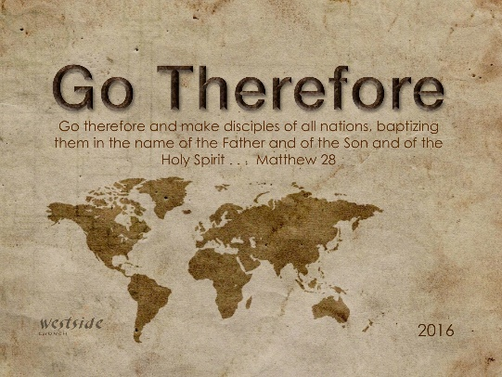
10-2-16

Romans #6

Just And Kind

What The Bible Says

Romans 2:1-11
You may think you can condemn such people, but you are just as bad, and you have no excuse! When you say they are wicked and should be punished, you are condemning yourself, for you who judge others do these very same things. ² And we know that God, in his justice, will punish anyone who does such things. ³ Since you judge others for doing these things, why do you think you can avoid God’s judgment when you do the same things? ⁴ Don’t you see how wonderfully kind, tolerant, and patient God is with you? Does this mean nothing to you? Can’t you see that his kindness is intended to turn you from your sin? ⁵ But because you are stubborn and refuse to turn from your sin, you are storing up terrible punishment for yourself. For a day of anger is coming, when God’s righteous judgment will be revealed. ⁶ He will judge everyone according to what they have done. ⁷ He will give eternal life to those who keep on doing good, seeking after the glory and honor and immortality that God offers. ⁸ But he will pour out his anger and wrath on those who live for themselves, who refuse to obey the truth and instead live lives of wickedness. ⁹ There will be trouble and calamity for everyone who keeps on doing what is evil—for the Jew first and also for the Gentile. ¹⁰ But there will be glory and honor and peace from God for all who do good—for the Jew first and also for the Gentile. ¹¹ For God does not show favoritism.

1. God Is _______________

All people are without excuse because all,
without exception, have sinned against God.

2. God Is ____________

Romans 2:4
Don’t you see how wonderfully kind, tolerant, and patient God is with you? Does this mean nothing to you? Can’t you see that his kindness is intended to turn you from your sin?

John 6:28-29
They replied, “We want to perform God’s works, too. What should we do?” ²⁹ Jesus told them, “This is the only work God wants from you: Believe in the one he has sent.”

3. “_______ ________” Is Coming

Matthew 24:36-42
“No one knows the day or hour when these things will happen, not even the angels in heaven or the Son himself. Only the Father knows. ³⁷ When the Son of Man returns, it will be like it was in Noah’s day. ³⁸ In those days before the flood, the people were enjoying banquets and parties and weddings right up to the time Noah entered his boat. ³⁹ People didn’t realize what was going to happen until the flood came and swept them all away. That is the way it will be when the Son of Man comes. ⁴⁰ Two men will be working together in the field; one will be taken, the other left. ⁴¹ Two women will be grinding flour at the mill; one will be taken, the other left. ⁴² “So you, too, must keep watch! For you don’t know what day your Lord is coming.”

Consequences occur frequently enough and intensely enough to work alongside God's patience to bring us to repentance.
-labc

1 Thessalonians 5:2-6
For you know quite well that the day of the Lord’s return will come unexpectedly, like a thief in the night. ³ When people are saying, “Everything is peaceful and secure,” then disaster will fall on them as suddenly as a pregnant woman’s labor pains begin. And there will be no escape. ⁴ But you aren’t in the dark about these things, dear brothers and sisters, and you won’t be surprised when the day of the Lord comes like a thief. ⁵ For you are all children of the light and of the day; we don’t belong to darkness and night. ⁶ So be on your guard, not asleep like the others. Stay alert and be clearheaded.

Application

Keep On

⁷ He will give eternal life to those who keep on doing good, seeking after the glory and honor and immortality that God offers.

- doing _____________

Matthew 5:16 (ESV)
¹⁶ In the same way, let your light shine before others, so that they may see your good works and give glory to your Father who is in heaven.

- pursuing ________________

Philippians 3:12-14
I don’t mean to say that I have already achieved these things or that I have already reached perfection. But I press on to possess that perfection for which Christ Jesus first possessed me. ¹³ No, dear brothers and sisters, I have not achieved it, but I focus on this one thing: Forgetting the past and looking forward to what lies ahead, ¹⁴ I press on to reach the end of the race and receive the heavenly prize for which God, through Christ Jesus, is calling us.

Ephesians 2:8-10 (ESV)
For by grace you have been saved through faith. And this is not your own doing; it is the gift of God, ⁹ not a result of works, so that no one may boast. ¹⁰ For we are his workmanship, created in Christ Jesus for good works, which God prepared beforehand, that we should walk in them.

We don’t serve Him ________ he’ll love us
we serve Him ___________________ he loves us!

Response:
What is God speaking to me?

Specifically, how will I obey Him?

