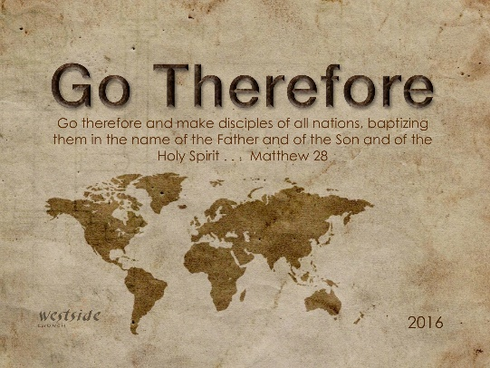
9-25-16

Romans #5

We All Worship Something

What The Bible Says

Romans 1:20-32
For ever since the world was created, people have seen the earth and sky. Through everything God made, they can clearly see his invisible qualities—his eternal power and divine nature. So they have no excuse for not knowing God. ²¹ Yes, they knew God, but they wouldn’t worship him as God or even give him thanks. And they began to think up foolish ideas of what God was like. As a result, their minds became dark and confused ²² Claiming to be wise, they instead became utter fools. ²³ And instead of worshiping the glorious, ever-living God, they worshiped idols made to look like mere people and birds and animals and reptiles. ²⁴ So God abandoned them to do whatever shameful things their hearts desired. As a result, they did vile and degrading things with each other’s bodies. ²⁵ They traded the truth about God for a lie. So they worshiped and served the things God created instead of the Creator himself, who is worthy of eternal praise! Amen. ²⁶ That is why God abandoned them to their shameful desires. Even the women turned against the natural way to have sex and instead indulged in sex with each other. ²⁷ And the men, instead of having normal sexual relations with women, burned with lust for each other. Men did shameful things with other men, and as a result of this sin, they suffered within themselves the penalty they deserved. ²⁸ Since they thought it foolish to acknowledge God, he abandoned them to their foolish thinking and let them do things that should never be done. ²⁹ Their lives became full of every kind of wickedness, sin, greed, hate, envy, murder, quarreling, deception, malicious behavior, and gossip. ³⁰ They are backstabbers, haters of God, insolent, proud, and boastful. They invent new ways of sinning, and they disobey their parents. ³¹ They refuse to understand, break their promises, are heartless, and have no mercy. ³² They know God’s justice requires that those who do these things deserve to die, yet they do them anyway. Worse yet, they encourage others to do them, too.

1. We were created to _______________

²³ And instead of worshiping the glorious, ever-living God, they worshiped idols made to look like mere people and birds and animals and reptiles. ²⁴ So God abandoned them to do whatever shameful things their hearts desired.

“When people and nations refuse to repent, sin takes over and draws people into a life where there is no sense of right and wrong. Without God's remedy, his righteousness, the end is destruction.”
-labc

2. Idolatry is worshipping something or someone other than ___________________________

^{Romans 1:25} They traded the truth about God for a lie. So they worshiped and served the things God created instead of the Creator himself, who is worthy of eternal praise! Amen.

“When we worship an idol in His place, He is no longer the one thing we have to have in this life; something else is. It rules us, and ultimately we will do anything – no matter how destructive to ourselves or others –
to have it, increase it, or keep it.”
-Tim Keller

3. Historically, some of the church hasn’t represented this ______.

Paul is not saying: It doesn’t matter what you do; God doesn’t mind as long as you’re happy. But he is also not saying: What you do matters so much that I don’t want to love you or witness to you, because you are beyond the Gospel.
-Tim Keller
Temptation is not sin – even Jesus was tempted

Application

1. Idolatry is much easier to see in others than in ______________

³² They know God’s justice requires that those who do these things deserve to die, yet they do them anyway. Worse yet, they encourage others to do them, too.

Question:
Do we encourage others to commit the sin of idolatry?

Question:
What idols could be, or might be jostling for a place in our hearts above God?

2. Preach the Gospel to ________________ every day

Romans 2:1
You may think you can condemn such people, but you are just as bad, and you have no excuse! When you say they are wicked and should be punished, you are condemning yourself, for you who judge others do these very same things.

We are ALL in desperate need of a Savior !!

Response:

What is God speaking to me?

Specifically, how will I obey Him?

