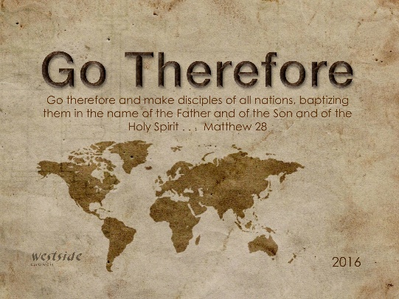**9-18-16**

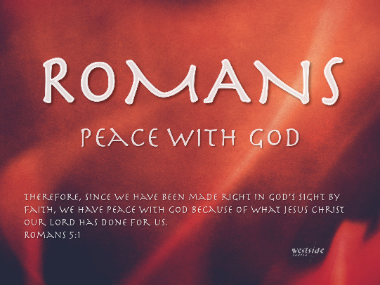



Romans #4

**No Excuse**

What The Bible Says

Romans 1:16-20

For I am not ashamed of this Good News about Christ. It is the power of God at work, saving everyone who believes—the Jew first and also the Gentile. 17  This Good News tells us how God makes us right in his sight. This is accomplished from start to finish by faith. As the Scriptures say, “It is through faith that a righteous person has life.” 18  But God shows his anger from heaven against all sinful, wicked people who suppress the truth by their wickedness. 19  They know the truth about God because he has made it obvious to them. 20  For ever since the world was created, people have seen the earth and sky. Through everything God made, they can clearly see his invisible qualities—his eternal power and divine nature. So they have ***no excuse*** for not knowing God.

## 1. Creation

**____________________:**

“*The machine code of the genes*

*is uncannily computer-like.*”

-Richard Dawkins

renowned atheist

**______________________________:**

Mathematics: zero probability !

**The ____________________:**

The Kalam argument states:  
  
1. Everything which begins to exist has a cause apart from itself.   
2. The universe began to exist.   
3. Therefore, the universe has a cause apart from itself.

*“Essentially, I realized that to stay an atheist, I would have to believe that nothing produces everything; non-life produces life; randomness produces fine-tuning; chaos produces information; unconsciousness produces consciousness; and non-reason produces reason. Those leaps of faith were simply too big for me to take, especially in light of the affirmative case for God's existence … In other words, in my assessment the Christian worldview accounted for the totality of the evidence much better than the atheistic worldview.”*

-Lee Strobel

former atheist

## 2. Conscience

**___________________:**

*Right and wrong imply a higher standard or law, and law requires a lawgiver. Because the Moral Law transcends humanity, this universal law requires a universal lawgiver. This, it is argued, is God.*

## 3. _____________

Colossians 1:15-17 (NLT)   
15  Christ is the visible image of the invisible God. He existed before anything was created and is supreme over all creation, 16  for through him God created everything in the heavenly realms and on earth. He made the things we can see and the things we can’t see— such as thrones, kingdoms, rulers, and authorities in the unseen world. Everything was created through him and for him. 17  He existed before anything else, and he holds all creation together.

Application

## 1. How Can God hold someone accountable if they do not know the Truth?

1:19  They know the truth about God because he has made it obvious to them. 20  For ever since the world was created, people have seen the earth and sky. Through everything God made, they can clearly see his invisible qualities—his eternal power and divine nature. So they have ***no excuse*** for not knowing God.

## 2. You ___________ know the Truth!

John 14:6 (NLT)   
6  Jesus told him, “I am the way, the truth, and the life. No one can come to the Father except through me.

Response:

What is God speaking to me?

## Specifically, how will I obey Him?