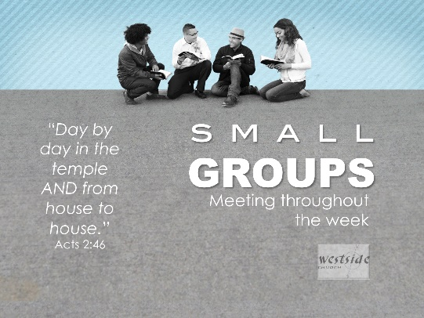
8-21-16

House To House

Acts 2:42-47 (NKJV)
And they continued steadfastly in the apostles' doctrine and fellowship, in the breaking of bread, and in prayers. ⁴³ Then fear came upon every soul, and many wonders and signs were done through the apostles. ⁴⁴ Now all who believed were together, and had all things in common, ⁴⁵ and sold their possessions and goods, and divided them among all, as anyone had need. ⁴⁶ So continuing daily with one accord in the temple, and breaking bread from house to house, they ate their food with gladness and simplicity of heart, ⁴⁷ praising God and having favor with all the people. And the Lord added to the church daily those who were being saved.

"The church isn't as effective when the shepherd ministers to the body, as the when the body ministers to the body."
-Perry Noble

1. For All Saints

Ephesians 4:11-16
Now these are the gifts Christ gave to the church: the apostles, the prophets, the evangelists, and the pastors and teachers. ¹² Their responsibility is to equip God’s people to do his work and build up the church, the body of Christ. ¹³ This will continue until we all come to such unity in our faith and knowledge of God’s Son that we will be mature in the Lord, measuring up to the full and complete standard of Christ. ¹⁴ Then we will no longer be immature like children. We won’t be tossed and blown about by every wind of new teaching. We will not be influenced when people try to trick us with lies so clever they sound like the truth. ¹⁵ Instead, we will speak the truth in love, growing in every way more and more like Christ, who is the head of his body, the church. ¹⁶ He makes the whole body fit together perfectly. As each part does its own special work, it helps the other parts grow, so that the whole body is healthy and growing and full of love.

Time With God:

Spending time with The Lord will help you become a more effective (growing, maturing, authentic, impacting, grace extending, witnessing, loving others) . . . disciple of Jesus.

It will help you:

A. Become a more mature follower of Jesus Christ.

1 Timothy 4:14-16 (NIV)
Do not neglect your gift, which was given you through a prophetic message when the body of elders laid their hands on you. ¹⁵ Be diligent in these matters; give yourself wholly to them, so that everyone may see your progress. ¹⁶ Watch your life and doctrine closely. Persevere in them, because if you do, you will save both yourself and your hearers.

- Life
- Gifting
- Doctrine

B. Rely on the guidance of the Holy Spirit.

2. For Small Group Leaders

Small Groups are the primary drivers of
- evangelism,
- discipleship,
- and care

Small Group Leadership Input:

#1 you’re not doing it for us – must be Jesus!

#2 the church will not survive without you – will implode . . .

#3 it’s a God-ordained and vital ministry

#4 the healthy relationships you facilitate will propel the church into unity, strength, and life

YOU ARE ABSOLUTELY CRITICAL IN LIFE OF CHURCH!!

3. Small Groups:

A. What exactly is a small group?

“A small group is a group of no more than 15 people who gather together regularly for the purpose of fellowship, prayer, and authentic community centered around the application of God’s Word to their daily lives.”

B. What is the purpose of a small group?

To Produce Changed Lives!

C. What does a healthy small group look like?

A healthy small group will be:

The fruitful place where leaders and servants are born in the atmosphere of a healthy balance of pastoring, discipleship & fellowship.

D. What does a typical meeting look like?

A blend of:

- Food: break bread together
- Relational: to each other
  - also to the church & eldership
- Intercede: pray for one another
- Encourage: all the gifts
- New Stuff: dynamic – contextualize - fun
- Demonstrate: Jesus to the world
- Study: the Word

E. What Are The Expectations of Westside Small Group Leaders?

Response:

What is God speaking to me?

Specifically, how will I obey Him?

