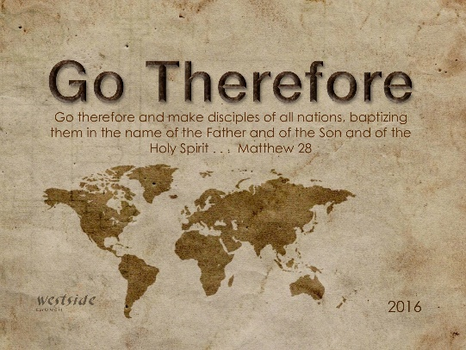
9-4-16

Romans #2

You Are Included

What The Bible Says

Romans 1:1-15
This letter is from Paul, a slave of Christ Jesus, chosen by God to be an apostle and sent out to preach his Good News. ² God promised this Good News long ago through his prophets in the holy Scriptures. ³ The Good News is about his Son, Jesus. In his earthly life he was born into King David’s family line, ⁴ and he was shown to be the Son of God when he was raised from the dead by the power of the Holy Spirit. He is Jesus Christ our Lord. ⁵ Through Christ, God has given us the privilege and authority as apostles to tell Gentiles everywhere what God has done for them, so that they will believe and obey him, bringing glory to his name. ⁶ And you are included among those Gentiles who have been called to belong to Jesus Christ. ⁷ I am writing to all of you in Rome who are loved by God and are called to be his own holy people. May God our Father and the Lord Jesus Christ give you grace and peace. ⁸ Let me say first that I thank my God through Jesus Christ for all of you, because your faith in him is being talked about all over the world. ⁹ God knows how often I pray for you. Day and night I bring you and your needs in prayer to God, whom I serve with all my heart by spreading the Good News about his Son. ¹⁰ One of the things I always pray for is the opportunity, God willing, to come at last to see you. ¹¹ For I long to visit you so I can bring you some spiritual gift that will help you grow strong in the Lord. ¹² When we get together, I want to encourage you in your faith, but I also want to be encouraged by yours. ¹³ I want you to know, dear brothers and sisters, that I planned many times to visit you, but I was prevented until now. I want to work among you and see spiritual fruit, just as I have seen among other Gentiles. ¹⁴ For I have a great sense of obligation to people in both the civilized world and the rest of the world, to the educated and uneducated alike. ¹⁵ So I am eager to come to you in Rome, too, to preach the Good News.

Encouragement

John 16:33 (NASB)
"These things I have spoken to you, that in Me you may have peace. In the world you have tribulation, but take courage; I have overcome the world."

1 Thes. 5:11 (NIV)
11 Therefore encourage one another and build each other up, just as in fact you are doing.

1 Corinthians 14:1-3 (NLT)
¹ Let love be your highest goal! But you should also desire the special abilities the Spirit gives—especially the ability to prophesy. ² For if you have the ability to speak in tongues, you will be talking only to God, since people won’t be able to understand you. You will be speaking by the power of the Spirit, but it will all be mysterious. ³ But one who prophesies strengthens others, encourages them, and comforts them.

The Holy Spirit’s power and presence is the source and reservoir from which we are encouraged and our encouragement toward others is given.

1. has _____________________ qualities

Proverbs 16:24 (NIV)
Pleasant words are a honeycomb,
sweet to the soul and healing to the bones.

2. is the best environment for ____________________

1 Cor. 14:31 (NIV)
For you can all prophesy in turn so that everyone may be instructed and encouraged.

3. creates its __________ environment

Acts 20:7-12 (NIV)
On the first day of the week we came together to break bread. Paul spoke to the people and, because he intended to leave the next day, kept on talking until midnight. . . [9] Seated in a window was a young man named Eutychus, who was sinking into a deep sleep as Paul talked on and on. When he was sound asleep, he fell to the ground from the third story and was picked up dead. [10] Paul went down, threw himself on the young man and put his arms around him. "Don't be alarmed," he said. "He's alive!" [11] Then he went upstairs again and broke bread and ate. After talking until daylight, he left. [12] The people took the young man home alive and were greatly comforted.

4. _________________ the casualty rate

1 Thes. 3:2 (NIV)
We sent Timothy, who is our brother and God's fellow worker in spreading the gospel of Christ, to strengthen and encourage you in your faith,

5. determines your ____________

Psalm 45:1
My heart overflows with a beautiful thought!
. . . for my tongue is like the pen of a skillful poet.

Suggestions:

1. _________________ up !!!!!

Proverbs 17:22 (NLT)
A cheerful heart is good medicine, but a broken spirit saps a person's strength.

2. think about ______________ things !!

Philip. 4:8 (NIV)
Finally, brothers, whatever is true, whatever is noble, whatever is right, whatever is pure, whatever is lovely, whatever is admirable--if anything is excellent or praiseworthy--think about such things.

3. speak ______________________

1 Thes. 5:11 (NLT)
So encourage each other and build each other up, just as you are already doing.

4. speak words of ____________ !!

Proverbs 18:21 (NIV)
The tongue has the power of life and death,
and those who love it will eat its fruit.

4. affirm people __________________

Romans 1:12
I'm eager to encourage you in your faith, but I also want to be encouraged by yours. In this way, each of us will be a blessing to the other.

Response:

What is God speaking to me?

Specifically, how will I obey Him?

