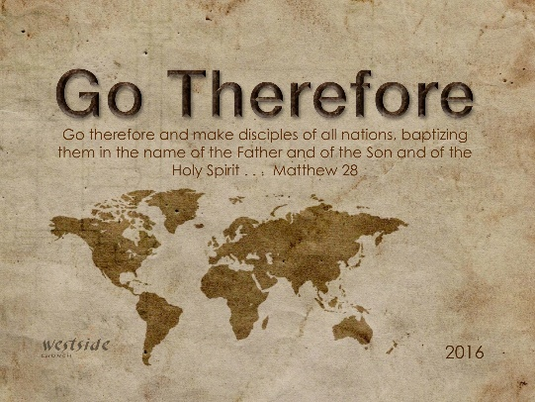
8-28-16
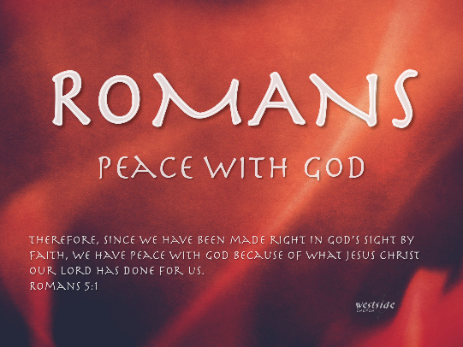

Romans #1

So That They Will Believe

Romans 1:1-7
This letter is from Paul, a slave of Christ Jesus, chosen by God to be an apostle and sent out to preach his Good News. ² God promised this Good News long ago through his prophets in the holy Scriptures. ³ The Good News is about his Son, Jesus. In his earthly life he was born into King David’s family line, ⁴ and he was shown to be the Son of God when he was raised from the dead by the power of the Holy Spirit. He is Jesus Christ our Lord. ⁵ Through Christ, God has given us the privilege and authority as apostles to tell Gentiles everywhere what God has done for them, so that they will believe and obey him, bringing glory to his name. ⁶ And you are included among those Gentiles who have been called to belong to Jesus Christ. ⁷ I am writing to all of you in Rome who are loved by God and are called to be his own holy people. (saints: holy or saint)) May God our Father and the Lord Jesus Christ give you grace and peace.

What The Bible Says

1. You can say ____ ______ with just a few words

Romans 1:1
This letter is from Paul, a slave of Christ Jesus, chosen by God to be an apostle and sent out to preach his Good News.
A. ___________________ Lives

Acts 9:1-19
Meanwhile, Saul was uttering threats with every breath and was eager to kill the Lord’s followers. So he went to the high priest. ² He requested letters addressed to the synagogues in Damascus, asking for their cooperation in the arrest of any followers of the Way he found there. He wanted to bring them—both men and women—back to Jerusalem in chains. ³ As he was approaching Damascus on this mission, a light from heaven suddenly shone down around him. ⁴ He fell to the ground and heard a voice saying to him, “Saul! Saul! Why are you persecuting me?” ⁵ “Who are you, lord?” Saul asked. And the voice replied, “I am Jesus, the one you are persecuting! ⁶ Now get up and go into the city, and you will be told what you must do.” ⁷ The men with Saul stood speechless, for they heard the sound of someone’s voice but saw no one! ⁸ Saul picked himself up off the ground, but when he opened his eyes he was blind. So his companions led him by the hand to Damascus. ⁹ He remained there blind for three days and did not eat or drink . . .

B. ________________________

Paul emphasizes that his authority is equal to that of the 12 apostles chosen by Christ.

- The apostles were specifically called by Christ (Matt. 10:1-7; Acts 1:24-26; Gal. 1:1)
- and had seen the risen Lord Jesus (Acts 1:22; 1 Cor. 9:1; 15:7-9).
- They established and governed the whole church, under Jesus Christ,
- and they had authority to speak and write the words of God, equal in authority to the OT Scriptures (1 Cor. 14:37; 2 Cor. 13:3; Gal. 1:8-9; 1 Thess. 2:13; 4:15; 2 Pet. 3:2, 15-16).

- Paul was called to be an apostle when Jesus appeared to him on the Damascus road (Acts 9; 22; 26; 1 Cor. 9:1; 15:8-9; Gal. 1:13-17),
- and the unusual timing of his called Paul to conclude that no more apostles would be chosen after him (1 Cor. 15:8).

Mark 10:43-45
But among you it will be different. Whoever wants to be a leader among you must be your servant, ⁴⁴ and whoever wants to be first among you must be the slave of everyone else. ⁴⁵ For even the Son of Man came not to be served but to serve others and to give his life as a ransom for many.”

C. ___________________
- original 12 special place in church history

from (apostello); a delegate; a sent one, messenger
- specially an ambassador of the Gospel;
- officially a commissioner of Christ
- generally . . . an apostle is a witness to the resurrection of Christ, sent by him to make disciples of all nations.

Matthew 28:19-20 (ESV)
Go therefore and make disciples of all nations, baptizing them in the name of the Father and of the Son and of the Holy Spirit, ²⁰ teaching them to observe all that I have commanded you. And behold, I am with you always, to the end of the age.”

Application

1. Have I ______________________ Jesus?

2. Do I live to ________________ Jesus?

3. Have I ___________________ a “going mindset?

Response:

What is God speaking to me?

Specifically, how will I obey Him?

