5-22-16
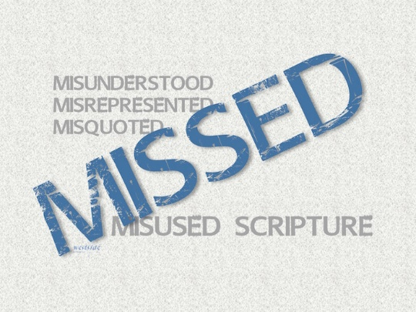

Don’t Judge Me!

What The Bible Says

Matthew 7:1-2 (NLT)
“Do not judge others, and you will not be judged. ² For you will be treated as you treat others. The standard you use in judging is the standard by which you will be judged.

1. Interpreting Scripture Faithfully

A. We approach God’s Word in ______________

B. We read “from” the text and not “___________ the text”

C. We work to understand the _________________

D. We let __________________ interpret scripture

E. We ______________ scripture to our lives

2. How ______ to judge

- in a harsh way

- in a hypocritical way

- in a prideful way

3. Is there a right way to judge?

A. In ________________ and gentleness

Galatians 6:1
Dear brothers and sisters, if another believer is overcome by some sin, you who are godly should gently and humbly help that person back onto the right path. And be careful not to fall into the same temptation yourself.

B. In ________________

James 5:19-20
My dear brothers and sisters, if someone among you wanders away from the truth and is brought back, ²⁰ you can be sure that whoever brings the sinner back will save that person from death and bring about the forgiveness of many sins.

C. In a spirit of ___________________

Matthew 18:15
“If another believer sins against you, go privately and point out the offense. If the other person listens and confesses it, you have won that person back.

We cannot accomplish this without the Power of the Holy Spirit !!

D. Keep judgment within the ____________

1 Corinthians 5:9-13
When I wrote to you before, I told you not to associate with people who indulge in sexual sin. ¹⁰ But I wasn’t talking about unbelievers who indulge in sexual sin, or are greedy, or cheat people, or worship idols. You would have to leave this world to avoid people like that. ¹¹ I meant that you are not to associate with anyone who claims to be a believer yet indulges in sexual sin, or is greedy, or worships idols, or is abusive, or is a drunkard, or cheats people. Don’t even eat with such people. ¹² It isn’t my responsibility to judge outsiders, but it certainly is your responsibility to judge those inside the church who are sinning. ¹³ God will judge those on the outside; but as the Scriptures say, “You must remove the evil person from among you.”

Application

1. Let’s address the sin in our ___________ _____________ first

1 John 1:8-9
If we claim we have no sin, we are only fooling ourselves and not living in the truth. ⁹ But if we confess our sins to him, he is faithful and just to forgive us our sins and to cleanse us from all wickedness.

2. When we do, let’s address sin in others gently and with ___________________

1. When a person has slipped, it is time for compassion not censoring.

Ephesians 4:32
. . . be kind to each other, tenderhearted, forgiving one another, just as God through Christ has forgiven you.

2. There is never a spirit of criticism in the humble and loving person. There is only a loving compassion for those who have come short

Galatians 6:2-3
Share each other’s burdens, and in this way obey the law of Christ. ³ If you think you are too important to help someone, you are only fooling yourself. You are not that important.

Response:

What is God speaking to me?

Specifically, how will I obey Him?

