4-10-16
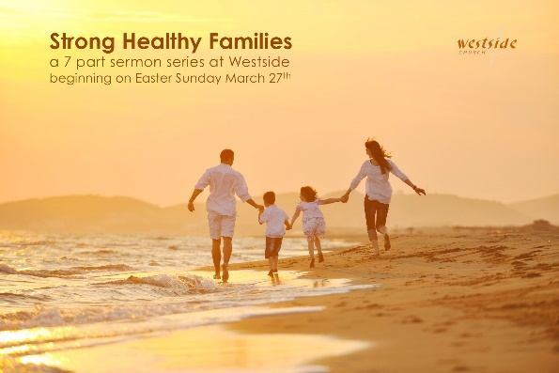

Strong Healthy Families Are Whole
physically emotionally spiritually

1 Thessalonians 5:12-24
Dear brothers and sisters, honor those who are your leaders in the Lord’s work. They work hard among you and give you spiritual guidance. ¹³ Show them great respect and wholehearted love because of their work. And live peacefully with each other. ¹⁴ Brothers and sisters, we urge you to warn those who are lazy. Encourage those who are timid. Take tender care of those who are weak. Be patient with everyone. ¹⁵ See that no one pays back evil for evil, but always try to do good to each other and to all people. ¹⁶ Always be joyful. ¹⁷ Never stop praying. ¹⁸ Be thankful in all circumstances, for this is God’s will for you who belong to Christ Jesus. ¹⁹ Do not stifle the Holy Spirit. ²⁰ Do not scoff at prophecies, ²¹ but test everything that is said. Hold on to what is good. ²² Stay away from every kind of evil. ²³ Now may the God of peace make you holy in every way, and may your whole spirit and soul and body be kept blameless until our Lord Jesus Christ comes again. ²⁴ God will make this happen, for he who calls you is faithful.

Body somah “body”
Soul psookhay “soul” or “life”
Spirit pneuma “breath”

1. Body

1 Timothy 4:8
“Physical training is good, but training for godliness is much better, promising benefits in this life and in the life to come.”

God has designed the human body so that it is a finely tuned instrument that is the most resilient on earth. It can endure fractures and adhesions, constant pain and great stretches of tedium. However, the human body is a fragile instrument because it is not built to handle excess, whether in the form of
nourishment, stress, abuse or trauma.

2. Spirit

Colossians 1:9-14
So we have not stopped praying for you since we first heard about you. We ask God to give you complete knowledge of his will and to give you spiritual wisdom and understanding. ¹⁰ Then the way you live will always honor and please the Lord, and your lives will produce every kind of good fruit. All the while, you will grow as you learn to know God better and better. ¹¹ We also pray that you will be strengthened with all his glorious power so you will have all the endurance and patience you need. May you be filled with joy, ¹² always thanking the Father. He has enabled you to share in the inheritance that belongs to his people, who live in the light. ¹³ For he has rescued us from the kingdom of darkness and transferred us into the Kingdom of his dear Son, ¹⁴ who purchased our freedom and forgave our sins.

3. Soul

Matthew 11:28-30
Then Jesus said, “Come to me, all of you who are weary and carry heavy burdens, and I will give you rest. ²⁹ Take my yoke upon you. Let me teach you, because I am humble and gentle at heart, and you will find rest for your souls. ³⁰ For my yoke is easy to bear, and the burden I give you is light.”

Application

1. ___________________ yourself well

1 Corinthians 6:19-20 (NLT)
¹⁹ Don’t you realize that your body is the temple of the Holy Spirit, who lives in you and was given to you by God? You do not belong to yourself, ²⁰ for God bought you with a high price. So you must honor God with your body.

being teachable… means that you are willing to relearn what you think you already know

2. Become whole and __________________ in:

Body

Spirit

General disciplines must to be a part of every Believer’s life:
- Reading and _______________ God's Word
- Gathering together with other believers ___________________
- __________________________
- Generous lifestyle
- __________________________
- Witnessing

Soul:

Response:

What is God speaking to me?

Specifically, how will I obey Him?

