3-13-16
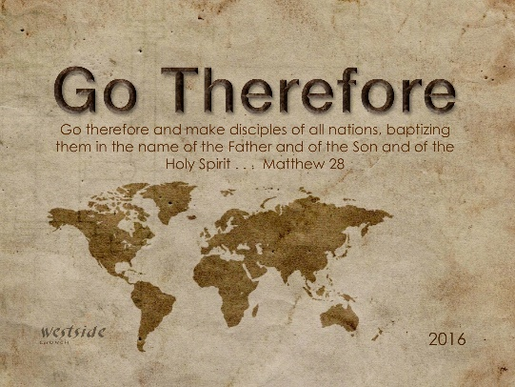

The Kind Of Church Jesus Has In Mind: Part 3

KIND:
A distinctive distinguishing trait, feature, or quality

1. A Church Filled With ________________ Power

2. ______________ Christian Fellowship

Acts 2:42-47 (NLT)
All the believers devoted themselves to the apostles’ teaching, and to fellowship, and to sharing in meals (including the Lord’s Supper), and to prayer. ⁴³ A deep sense of awe came over them all, and the apostles performed many miraculous signs and wonders. ⁴⁴ And all the believers met together in one place and shared everything they had. ⁴⁵ They sold their property and possessions and shared the money with those in need. ⁴⁶ They worshiped together at the Temple each day, met in homes for the Lord’s Supper, and shared their meals with great joy and generosity— ⁴⁷ all the while praising God and enjoying the goodwill of all the people. And each day the Lord added to their fellowship those who were being saved.

3. ___________________ Salvations:

Acts 2:47 (ESV)
. . . and the Lord added to their number day by day those who were being saved.

4. _____________________ Water Baptism

Acts 2:41
So those who received his word were baptized, and there were added that day about three thousand souls.

5. Corporate _______________

Acts 1:14
They all met together and were constantly united in prayer, along with Mary the mother of Jesus, several other women, and the brothers of Jesus.

Acts 2:1
On the day of Pentecost all the believers were meeting together in one place.

Acts 4:31
After this prayer, the meeting place shook, and they were all filled with the Holy Spirit. Then they preached the word of God with boldness.

Acts 4:23-24
As soon as they were freed, Peter and John returned to the other believers and told them what the leading priests and elders had said. ²⁴ When they heard the report, all the believers lifted their voices together in prayer to God: “O Sovereign Lord, Creator of heaven and earth, the sea, and everything in them—

2 Corinthians 1:9-11
In fact, we expected to die. But as a result, we stopped relying on ourselves and learned to rely only on God, who raises the dead. ¹⁰ And he did rescue us from mortal danger, and he will rescue us again. We have placed our confidence in him, and he will continue to rescue us. ¹¹ And you are helping us by praying for us. Then many people will give thanks because God has graciously answered so many prayers for our safety.

6. True ______________________

Luke 14:26-27
“If you want to be my disciple, you must hate everyone else by comparison—your father and mother, wife and children, brothers and sisters—yes, even your own life. Otherwise, you cannot be my disciple. ²⁷ And if you do not carry your own cross and follow me, you cannot be my disciple.

Luke 14:33
So you cannot become my disciple without giving up everything you own.

Luke 9:62
But Jesus told him, “Anyone who puts a hand to the plow and then looks back is not fit for the Kingdom of God.”

7. ______________________ Preaching

Acts 4:5-13 (NLT)
⁵ The next day the council of all the rulers and elders and teachers of religious law met in Jerusalem. ⁶ Annas the high priest was there, along with Caiaphas, John, Alexander, and other relatives of the high priest. ⁷ They brought in the two disciples and demanded, “By what power, or in whose name, have you done this?” ⁸ Then Peter, filled with the Holy Spirit, said to them, “Rulers and elders of our people, ⁹ are we being questioned today because we’ve done a good deed for a crippled man? Do you want to know how he was healed? ¹⁰ Let me clearly state to all of you and to all the people of Israel that he was healed by the powerful name of Jesus Christ the Nazarene, the man you crucified but whom God raised from the dead. ¹¹ For Jesus is the one referred to in the Scriptures, where it says, ‘The stone that you builders rejected has now become the cornerstone.’ ¹² There is salvation in no one else! God has given no other name under heaven by which we must be saved.” ¹³ The members of the council were amazed when they saw the boldness of Peter and John, for they could see that they were ordinary men with no special training in the Scriptures. They also recognized them as men who had been with Jesus.

John Wesley:
“When I prepare - the Holy Spirit activates a light in me,
when I preach – people watch me burn.”

Application

How will this apply to my life?

- constant salvations
- immediate baptisms
- corporate prayer
- true discipleship
- anointed preaching

Response:

What is God speaking to me?

Specifically, how will I obey Him?

