4-3-16
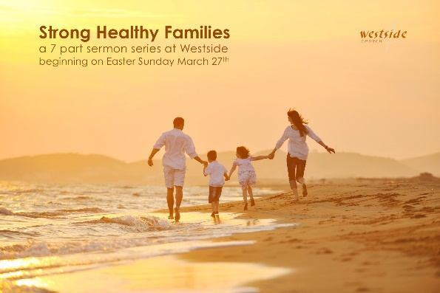

Strong Healthy Families:
Are Looking Forward

What The Bible Says

Ephesians 4:17-32
With the Lord’s authority I say this: Live no longer as the Gentiles do, for they are hopelessly confused. ¹⁸ Their minds are full of darkness; they wander far from the life God gives because they have closed their minds and hardened their hearts against him. ¹⁹ They have no sense of shame. They live for lustful pleasure and eagerly practice every kind of impurity. ²⁰ But that isn’t what you learned about Christ. ²¹ Since you have heard about Jesus and have learned the truth that comes from him, ²² throw off your old sinful nature and your former way of life, which is corrupted by lust and deception. ²³ Instead, let the Spirit renew your thoughts and attitudes. ²⁴ Put on your new nature, created to be like God—truly righteous and holy. ²⁵ So stop telling lies. Let us tell our neighbors the truth, for we are all parts of the same body. ²⁶ And “don’t sin by letting anger control you.” Don’t let the sun go down while you are still angry, ²⁷ for anger gives a foothold to the devil. ²⁸ If you are a thief, quit stealing. Instead, use your hands for good hard work, and then give generously to others in need. ²⁹ Don’t use foul or abusive language. Let everything you say be good and helpful, so that your words will be an encouragement to those who hear them. ³⁰ And do not bring sorrow (GRIEVE) to God’s Holy Spirit by the way you live. Remember, he has identified you as his own, guaranteeing that you will be saved on the day of redemption. ³¹ Get rid of all bitterness, rage, anger, harsh words, and slander, as well as all types of evil behavior. ³² Instead, be kind to each other, tenderhearted, forgiving one another, just as God through Christ has forgiven you.

1 Corinthians 13:4-7 (ESV)
Love is patient and kind; love does not envy or boast; it is not arrogant ⁵ or rude. It does not insist on its own way; it is not irritable or resentful; ⁶ it does not rejoice at wrongdoing, but rejoices with the truth. ⁷ Love bears all things, believes all things, hopes all things, endures all things.

1. Love never ____________ ______

“Love bears all things”

Love takes no pleasure in exposing the
wrong and weaknesses of others.

2. Love never loses _____________

“Love believes all things”

Love gives the benefit of the doubt

3. Love is always _________________

“Love hopes all things”

Believers who love look forward, not backward

4. Love _________________ through every circumstance

“Love endures all things”

They hang on when the going gets tough

Application

1. Understand that _______________________is on a journey

Philippians 1:6
And I am certain that God, who began the good work within you, will continue his work until it is finally finished on the day when Christ Jesus returns.

2. Choose to look at people like ____________________ does

2 Corinthians 5:16-17

So we have stopped evaluating others from a human point of view. At one time we thought of Christ merely from a human point of view. How differently we know him now! ¹⁷ This means that anyone who belongs to Christ has become a new person. The old life is gone; a new life has begun!

3. Live looking ______________________

Philippians 3:12-14
I don’t mean to say that I have already achieved these things or that I have already reached perfection. But I press on to possess that perfection for which Christ Jesus first possessed me. ¹³ No, dear brothers and sisters, I have not achieved it, but I focus on this one thing: Forgetting the past and looking forward to what lies ahead, ¹⁴ I press on to reach the end of the race and receive the heavenly prize for which God, through Christ Jesus, is calling us.

Response:

What is God speaking to me?

Specifically, how will I obey Him?

