2-28-16
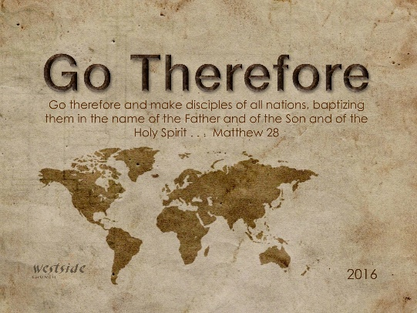

part 1 – Feb 28

The Kind Of Church Jesus Had In Mind

Acts 10:34-46
Then Peter replied, “I see very clearly that God shows no favoritism. ³⁵ In every nation he accepts those who fear him and do what is right. ³⁶ This is the message of Good News for the people of Israel—that there is peace with God through Jesus Christ, who is Lord of all. ³⁷ You know what happened throughout Judea, beginning in Galilee, after John began preaching his message of baptism. ³⁸ And you know that God anointed Jesus of Nazareth with the Holy Spirit and with power. Then Jesus went around doing good and healing all who were oppressed by the devil, for God was with him. ³⁹ “And we apostles are witnesses of all he did throughout Judea and in Jerusalem. They put him to death by hanging him on a cross, ⁴⁰ but God raised him to life on the third day. Then God allowed him to appear, ⁴¹ not to the general public, but to us whom God had chosen in advance to be his witnesses. We were those who ate and drank with him after he rose from the dead. ⁴² And he ordered us to preach everywhere and to testify that Jesus is the one appointed by God to be the judge of all—the living and the dead. ⁴³ He is the one all the prophets testified about, saying that everyone who believes in him will have their sins forgiven through his name.” ⁴⁴ Even as Peter was saying these things, the Holy Spirit fell upon all who were listening to the message. ⁴⁵ The Jewish believers who came with Peter were amazed that the gift of the Holy Spirit had been poured out on the Gentiles, too. ⁴⁶ For they heard them speaking in tongues and praising God.

“kind”
- A distinctive distinguishing trait, feature, or quality

1. A Church Filled With _________________________ Power

Acts 1:8
But you will receive power when the Holy Spirit comes upon you. And you will be my witnesses, telling people about me everywhere—in Jerusalem, throughout Judea, in Samaria, and to the ends of the earth.”

Acts 2:1-4
On the day of Pentecost all the believers were meeting together in one place. ² Suddenly, there was a sound from heaven like the roaring of a mighty windstorm, and it filled the house where they were sitting. ³ Then, what looked like flames or tongues of fire appeared and settled on each of them. ⁴ And everyone present was filled with the Holy Spirit and began speaking in other languages, as the Holy Spirit gave them this ability.

A. witnesses
Acts 1:8

B. signs, _________________, healings

Acts 6:8
Stephen, a man full of God’s grace and power, performed amazing miracles and signs among the people.

C. power to _____________________ – no matter what

Galatians 5:22-23
But the Holy Spirit produces this kind of fruit in our lives: love, joy, peace, patience, kindness, goodness, faithfulness, ²³ gentleness, and self-control. There is no law against these things!

“I believe that the number one sign
a person is filled with the Holy Spirit is that
they live a Godly victorious life.” (Gal 5:22-23)

D. prerequisite for ________________

Acts 6:3
And so, brothers, select seven men who are well respected and are full of the Spirit and wisdom. We will give them this responsibility.

Romans 8:2
And because you belong to him, the power of the life-giving Spirit has freed you from the power of sin that leads to death.

E. must have H.S. to ________________

1 Corinthians 12:3
So I want you to know that no one speaking by the Spirit of God will curse Jesus, and no one can say Jesus is Lord, except by the Holy Spirit.

F. Gifts of the Spirit in ____________________________:
- church
- homes
- marketplace

1 Corinthians 14:1-5
Let love be your highest goal! But you should also desire the special abilities the Spirit gives—especially the ability to prophesy. ² For if you have the ability to speak in tongues, you will be talking only to God, since people won’t be able to understand you. You will be speaking by the power of the Spirit, but it will all be mysterious. ³ But one who prophesies strengthens others, encourages them, and comforts them. ⁴ A person who speaks in tongues is strengthened personally, but one who speaks a word of prophecy strengthens the entire church. ⁵ I wish you could all speak in tongues, but even more I wish you could all prophesy. For prophecy is greater than speaking in tongues, unless someone interprets what you are saying so that the whole church will be strengthened.

1 Corinthians 14:26-29, 30
Well, my brothers and sisters, let’s summarize. When you meet together, one will sing, another will teach, another will tell some special revelation God has given, one will speak in tongues, and another will interpret what is said. But everything that is done must strengthen all of you. ²⁷ No more than two or three should speak in tongues. They must speak one at a time, and someone must interpret what they say. ²⁸ But if no one is present who can interpret, they must be silent in your church meeting and speak in tongues to God privately. ²⁹ Let two or three people prophesy, and let the others evaluate what is said . . . ³⁹ So, my dear brothers and sisters, be eager to prophesy, and don’t forbid speaking in tongues. ⁴⁰ But be sure that everything is done properly and in order.

The Kind Of Church Jesus Had In Mind
(part 2 Mar 6)

Response:

What is God speaking to me?

Specifically, how will I obey Him?

