1-17-16

Faith Is Required To Go And Not Settle

What The Bible Says

Genesis 11:27-32
This is the account of Terah’s family. Terah was the father of Abram, Nahor, and Haran; and Haran was the father of Lot. ²⁸ But Haran died in Ur of the Chaldeans, the land of his birth, while his father, Terah, was still living. ²⁹ Meanwhile, Abram and Nahor both married. The name of Abram’s wife was Sarai, and the name of Nahor’s wife was Milcah. (Milcah and her sister Iscah were daughters of Nahor’s brother Haran.) ³⁰ But Sarai was unable to become pregnant and had no children. ³¹ One day Terah took his son Abram, his daughter-in-law Sarai (his son Abram’s wife), and his grandson Lot (his son Haran’s child) and moved away from Ur of the Chaldeans. He was headed for the land of Canaan, but they stopped at Haran and settled there. ³² Terah lived for 205 years and died while still in Haran.

Hebrews 11:8-12
It was by faith that Abraham obeyed when God called him to leave home and go to another land that God would give him as his inheritance. He went without knowing where he was going. ⁹ And even when he reached the land God promised him, he lived there by faith—for he was like a foreigner, living in tents. And so did Isaac and Jacob, who inherited the same promise. ¹⁰ Abraham was confidently looking forward to a city with eternal foundations, a city designed and built by God. ¹¹ It was by faith that even Sarah was able to have a child, though she was barren and was too old. She believed that God would keep his promise. ¹² And so a whole nation came from this one man who was as good as dead—a nation with so many people that, like the stars in the sky and the sand on the seashore, there is no way to count them.
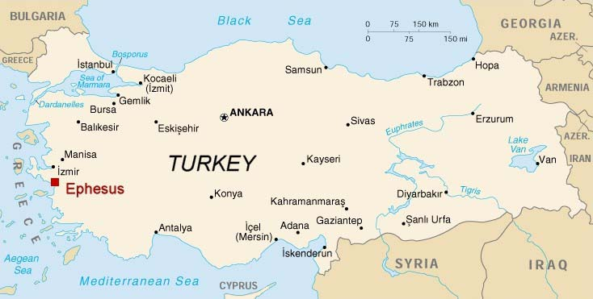

Ephesus:

Revelation 2:1-5
“Write this letter to the angel of the church in Ephesus. This is the message from the one who holds the seven stars in his right hand, the one who walks among the seven gold lampstands: ² “I know all the things you do. I have seen your hard work and your patient endurance. I know you don’t tolerate evil people. You have examined the claims of those who say they are apostles but are not. You have discovered they are liars. ³ You have patiently suffered for me without quitting. ⁴ “But I have this complaint against you. You don’t love me or each other as you did at first! ⁵ Look how far you have fallen! Turn back to me and do the works you did at first. If you don’t repent, I will come and remove your lampstand from its place among the churches.

Commended:
- _______________ deeds
- _______________ _____________
- perseverance
- cannot tolerate wickedness
- tested claims of people
- endured _________________
- not grown weary

What God Had Against Them:
- ______________ their first love

Remedy:

- ____________________________:

- ____________________________:

- ____________________________:

Questions:
How about you?
- doing many “things” right?
- working hard for the Kingdom?
- but just going through the motions?

What will happen if we don’t repent?
“If you do not repent, I will come to you and remove your lampstand from its place.”

Have you _________________ ?

Have you lost your first ___________________ ?

Have we __________________ ?

Have ________ lost our first love ?

Let’s not let our light be removed from us . . .

Response:

What is God speaking to me?

Specifically, how will I obey Him?

