9-6-15

Authentic

An Authentic Believer: Obeys God’s Word

1 John 2:1-6
My dear children, I am writing this to you so that you will not sin. But if anyone does sin, we have an advocate who pleads our case before the Father. He is Jesus Christ, the one who is truly righteous. ² He himself is the sacrifice that atones for our sins—and not only our sins but the sins of all the world. ³ And we can be sure that we know him if we obey his commandments. ⁴ If someone claims, “I know God,” but doesn’t obey God’s commandments, that person is a liar and is not living in the truth. ⁵ But those who obey God’s word truly show how completely they love him. That is how we know we are living in him. ⁶ Those who say they live in God should live their lives as Jesus did.

What The Bible Says

1. Don’t ______________.

Forsake all sin
- despise it
- stay free from it

What is sin?

- The 10 Commandments
- Our sin condition . . .
- literally the word means to: “_________ ______ __________”

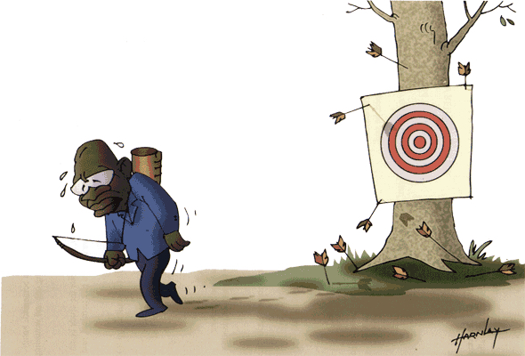

Romans 3:23 (ESV)
. . . for all have sinned and fall short of the glory of God.

Galatians 5:22-23
But the Holy Spirit produces this kind of fruit in our lives: love, joy, peace, patience, kindness, goodness, faithfulness, ²³ gentleness, and self-control. There is no law against these things!

“If you are fully and continuously filled with the Holy Spirit, you won’t ever have to worry about rules again!”
-sb

2. But if you do . . . we have an _________________.

Jesus Christ is our "Advocate"

Advocate:
”Someone who is called in to stand by the side of another. The purpose is to help in any way possible.”

a. What is it that gives Jesus the right to plead the believer’s case?

Jesus Christ is the _______________ _____.

God will never turn down a person who has Jesus Christ as his advocate. The person who has Jesus Christ to approach God for him will never be turned down, for Jesus Christ has the right to stand as the advocate before
God in the court of heaven.
-posb

b. What is it that Jesus Christ pleads?

He pleads His _____ ____________________.

(Application)

3. The ________________

When Jesus Christ carries a man's case before God,
He pleads His own righteousness and death, and God accepts His righteousness and death for man. It is by this, by the sacrifice of His death for our sins, that we become acceptable to God.
-posb

1 John 5:1-3
Everyone who believes that Jesus is the Christ has become a child of God. And everyone who loves the Father loves his children, too. ² We know we love God’s children if we love God and obey his commandments. ³ Loving God means keeping his commandments, and his commandments are not burdensome.

Response:

What is God speaking to me?

Specifically, how will I obey Him?

