8-23-15
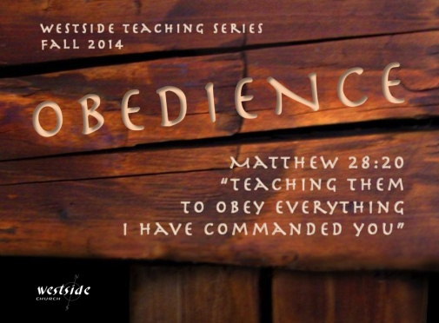

Authentic
Introduction

Moralistic Therapeutic Deism
consists of beliefs like these:

1. “A god exists who created and ordered the world and watches over human life on earth.”

2. “God wants people to be good, nice, and fair to each other, as taught in the Bible and by most world religions.”

3. “The central goal of life is to be happy and to feel good about one’s self.”

4. “God does not need to be particularly involved in one’s life except when God is needed to resolve a problem.”

5. “Good people go to heaven when they die.”

1 John 1:1-4
We proclaim to you the one who existed from the beginning, whom we have heard and seen. We saw him with our own eyes and touched him with our own hands. He is the Word of life. ² This one who is life itself was revealed to us, and we have seen him. And now we testify and proclaim to you that he is the one who is eternal life. He was with the Father, and then he was revealed to us. ³ We proclaim to you what we ourselves have actually seen and heard so that you may have fellowship with us. And our fellowship is with the Father and with his Son, Jesus Christ. ⁴ We are writing these things so that you may fully share our joy.

What The Bible Says

1. We __________________ Jesus

We ____________ Him
We __________________ Him
He ___________________ Himself to us

“No one who encountered Jesus
was ever the same again.”

2. We __________________ Jesus

Purpose: to fellowship with one another – and with God

1 John 1:3
We proclaim to you what we ourselves have actually seen and heard so that you may have fellowship with us. And our fellowship is with the Father and with his Son, Jesus Christ.

Four principles undergird true Christian fellowship:
- Christian fellowship is grounded in the testimony of God's ____
- Christian fellowship is _____________
- Christian fellowship is renewed ______ through the Holy Spirit
- Christian fellowship demands adherence to ___________
-labc

Application

1. Have _______encountered Jesus?

Acts 9:3-5
As he (Paul) was approaching Damascus on this mission, a light from heaven suddenly shone down around him. ⁴ He fell to the ground and heard a voice saying to him, “Saul! Saul! Why are you persecuting me?” ⁵ “Who are you, lord?” Saul asked. And the voice replied, “I am Jesus, the one you are persecuting!

John 3:16 (ESV)
“For God so loved the world, that he gave his only Son, that whoever believes in him should not perish but have eternal life.

2. Do you proclaim ____________?

Acts 4:18-20
So they called the apostles back in and commanded them never again to speak or teach in the name of Jesus. ¹⁹ But Peter and John replied, “Do you think God wants us to obey you rather than him? ²⁰ We cannot stop telling about everything we have seen and heard.”

Response:

What is God speaking to me?

Specifically, how will I obey Him?

