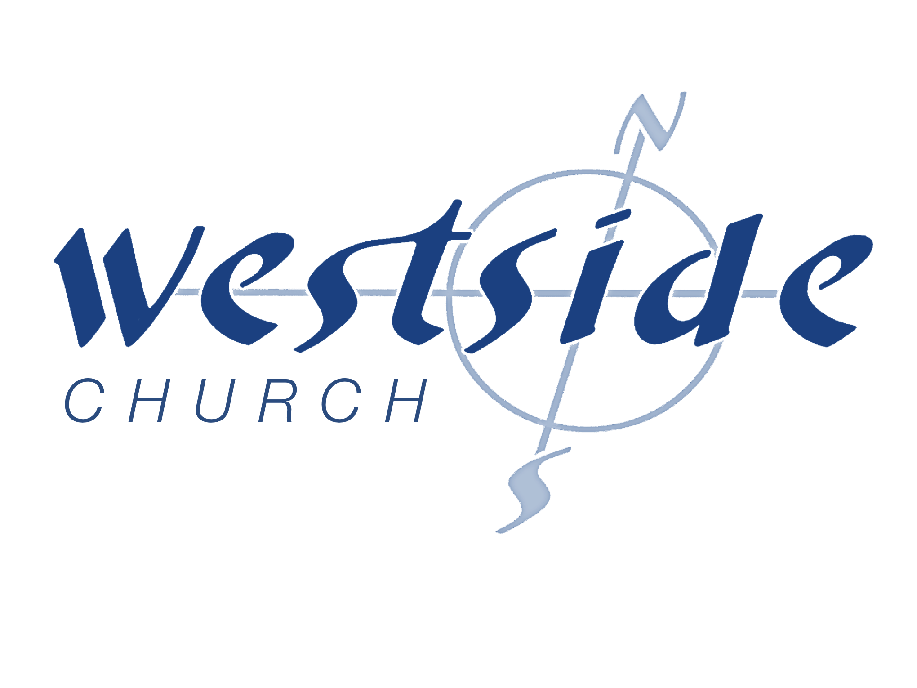
9-16-18
a follow up to Tyrone Daniel

What Matters Most

What The Bible Says

Revelation 21:1- 22:21
Then I saw a new heaven and a new earth, for the old heaven and the old earth had disappeared. And the sea was also gone. ² And I saw the holy city, the new Jerusalem, coming down from God out of heaven like a bride beautifully dressed for her husband. ³ I heard a loud shout from the throne, saying, “Look, God’s home is now among his people! He will live with them, and they will be his people. God himself will be with them. ⁴ He will wipe every tear from their eyes, and there will be no more death or sorrow or crying or pain. All these things are gone forever.” . . . ⁹ Then one of the seven angels who held the seven bowls containing the seven last plagues came and said to me, “Come with me! I will show you the bride, the wife of the Lamb.” (THE CHURCH) ¹⁰ So he took me in the Spirit to a great, high mountain, and he showed me the holy city, Jerusalem, descending out of heaven from God. ¹¹ It shone with the glory of God . . . ^{22:1} Then the angel showed me a river with the water of life, clear as crystal, flowing from the throne of God and of the Lamb. ² It flowed down the center of the main street. On each side of the river grew a tree of life, bearing twelve crops of fruit, with a fresh crop each month. The leaves were used for medicine to heal the nations. ³ No longer will there be a curse upon anything. For the throne of God and of the Lamb will be there, and his servants will worship him. ⁴ And they will see his face, and his name will be written on their foreheads. ⁵ And there will be no night there—no need for lamps or sun—for the Lord God will shine on them. And they will reign forever and ever.

¹³ I am the Alpha and the Omega, the First and the Last, the Beginning and the End.” . . . I am the bright morning star.” ¹⁷ The Spirit and the bride say, “Come.” Let anyone who hears this say, “Come.” Let anyone who is thirsty come. Let anyone who desires drink freely from the water of life . . . ²⁰ He who is the faithful witness to all these things says, “Yes, I am coming soon!” Amen! Come, Lord Jesus! ²¹ May the grace of the Lord Jesus be with God’s holy people.

Purpose of the Church

1. _______________________ the Bride

2 Corinthians 11:2
For I am jealous for you with the jealousy of God himself. I promised you as a pure bride to one husband—Christ.

Revelation 19:7
Let us be glad and rejoice, and let us give honor to him. For the time has come for the wedding feast of the Lamb, and his bride has prepared herself.

2. _________________________ the Nations

Matthew 28:19-20
Therefore, go and make disciples of all the nations, baptizing them in the name of the Father and the Son and the Holy Spirit. ²⁰ Teach these new disciples to obey all the commands I have given you. And be sure of this: I am with you always, even to the end of the age.”

3. _________________ New Testament Churches Everywhere

Planting churches is the only New Testament pattern!

What is an authentic New Testament Church?

A Church that:

- functions according to the New Testament Pattern

- understands it is created for relationship with God

- stays true to its’ purpose

Ephesians 3:10-11 (SBV)
God’s purpose in all this was that through the church to display his wisdom in its rich variety to all the unseen rulers and authorities in the heavenly places. ¹¹ This was his eternal plan, which he carried out through Christ Jesus our Lord.

- gives itself to not just the “good” things but to “God” things . . . the best things

- knows that it has a HUGE MANDATE

- knows God has called it to “take ground”

- stays simple

Acts 2:42
All the believers devoted themselves to the apostles’ teaching, and to fellowship, and to sharing in meals (including the Lord’s Supper), and to prayer.

4. _____________ – Train – Release Leaders

Leader = servant examples

5. ________________ ______ a Kingdom of Priests

Ephesians 4:11-13
Now these are the gifts Christ gave to the church: the apostles, the prophets, the evangelists, and the pastors and teachers. ¹² Their responsibility is to equip God’s people to do his work and build up the church, the body of Christ. ¹³ This will continue until we all come to such unity in our faith and knowledge of God’s Son that we will be mature in the Lord, measuring up to the full and complete standard of Christ.

6. ___________________________ the Lost

Matthew 9:37-38
He said to his disciples, “The harvest is great, but the workers are few. ³⁸ So pray to the Lord who is in charge of the harvest; ask him to send more workers into his fields.”

John 3:16
“For God loved the world so much that he gave his one and only Son, so that everyone who believes in him will not perish but have eternal life.

So what’s the most important thing we do ?

- Evangelize the lost . . .
- Raise up the priesthood . . .
- Equip & release leaders . . .
- Plant N.T. churches everywhere . . .
- Disciple the nations . . .
- Prepare the church for His return !!

What Is My Response ?

Hebrews 10:23-25
Let us hold tightly without wavering to the hope we affirm, for God can be trusted to keep his promise. ²⁴ Let us think of ways to motivate one another to acts of love and good works. ²⁵ And let us not neglect our meeting together, as some people do, but encourage one another, especially now that the day of his return is drawing near.

Response:

What is God speaking to me?

Specifically, how will I obey Him?

