5-20-18
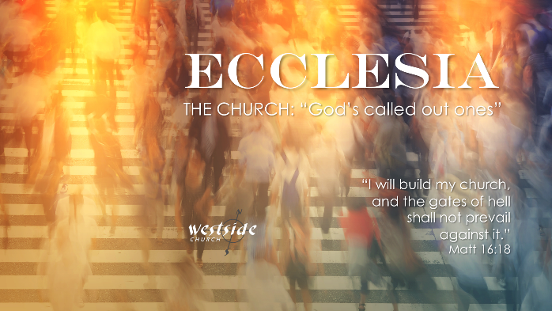

Ecclesia #19
Signs of a
Healthy Church
in Philippians

Surpassing Worth of Jesus Christ

What The Bible Says:

Philippians 3:1-12
Finally, my brothers, rejoice in the Lord. To write the same things to you is no trouble to me and is safe for you.² Look out for the dogs, look out for the evildoers, look out for those who mutilate the flesh. ³ For we are the circumcision, who worship by the Spirit of God and glory in Christ Jesus and put no confidence in the flesh— ⁴ though I myself have reason for confidence in the flesh also. If anyone else thinks he has reason for confidence in the flesh, I have more: ⁵ circumcised on the eighth day, of the people of Israel, of the tribe of Benjamin, a Hebrew of Hebrews; as to the law, a Pharisee; ⁶ as to zeal, a persecutor of the church; as to righteousness under the law, blameless. ⁷ But whatever gain I had, I counted as loss for the sake of Christ. ⁸ Indeed, I count everything as loss because of the surpassing worth of knowing Christ Jesus my Lord. For his sake I have suffered the loss of all things and count them as rubbish, in order that I may gain Christ ⁹ and be found in him, not having a righteousness of my own that comes from the law, but that which comes through faith in Christ, the righteousness from God that depends on faith— ¹⁰ that I may know him and the power of his resurrection, and may share his sufferings, becoming like him in his death, ¹¹ that by any means possible I may attain the resurrection from the dead.¹² Not that I have already obtained this or am already perfect, but I press on to make it my own, because Christ Jesus has made me his own

1. They are ___________________:

Finally, my brothers, rejoice in the Lord

This is a command
Regardless of your circumstances

2. They are ___________________:

Philippians 3:2
Look out for the dogs, look out for the evildoers, look out for those who mutilate the flesh.

Self-reliance as a basis for righteousness is the evil work.

3. They place no confidence in ____________________:

Philippians 3:3
For we are the circumcision, who worship by the Spirit of God and glory in Christ Jesus and put no confidence in the flesh.

Genesis 15:6
6 And he believed the Lord, and he counted it to him as righteousness.

God is more concerned with our hearts

Romans 2:29
… circumcision is a matter of the heart, by the Spirit, not by the letter.

4. They are a people who choose ___________________ over everything and anything else:

Philippians 3:8
I count everything as loss because of the surpassing worth of knowing Christ Jesus my Lord.

Job 19:25
For I know that my Redeemer lives,
and at the last He will stand upon the earth

Make a decision between anything this world can offer – and knowing Jesus

Justification:

Sanctification:

Glorification:

5. They are a people that move _________________

God demonstrates His love for you:
Romans 5:8;11
but God shows his love for us in that while we were still sinners, Christ died for us...we also rejoice in God through our Lord Jesus Christ, through whom we have now received reconciliation.

God wants your full devotion and attention.

Response:

What is God speaking to me?

Specifically, how will I obey Him?

