10-23-16
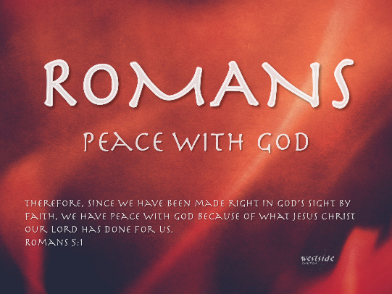

Romans #8

OF THE HEART, BY THE SPIRIT

Romans 2:17-29 (NASB)
¹⁷ But if you bear the name "Jew" and rely upon the Law and boast in God, ¹⁸ and know His will and approve the things that are essential, being instructed out of the Law, ¹⁹ and are confident that you yourself are a guide to the blind, a light to those who are in darkness, ²⁰ a corrector of the foolish, a teacher of the immature, having in the Law the embodiment of knowledge and of the truth, ²¹ you, therefore, who teach another, do you not teach yourself? You who preach that one shall not steal, do you steal? ²² You who say that one should not commit adultery, do you commit adultery? You who abhor idols, do you rob temples? ²³ You who boast in the Law, through your breaking the Law, do you dishonor God? ²⁴ For “the name of God is blasphemed among the Gentiles because of you,” just as it is written.

²⁵ For indeed circumcision is of value if you practice the Law; but if you are a transgressor of the Law, your circumcision has

become uncircumcision. ²⁶ So if the uncircumcised man keeps the requirements of the Law, will not his uncircumcision be regarded as circumcision? ²⁷ And he who is physically uncircumcised, if he keeps the Law, will he not judge you who though having the letter of the Law and circumcision are a transgressor of the Law? ²⁸ For he is not a Jew who is one outwardly, nor is circumcision that which is outward in the flesh.
²⁹ But he is a Jew who is one inwardly; and circumcision is that which is of the heart, by the Spirit, not by the letter; and his praise is not from men, but from God.

It is good to know and agree with all the right things.

- The Jewish people knew they had been chosen by God for a special purpose.
- They had been entrusted with God’s revelation of both the Law of Moses, and the prophets.
- They not only knew His will but approved of it and agreed with it.
- Because of their “special status” they viewed themselves as teachers, correctors, guides and lights.

James 2:19 (NASB)
¹⁹ You believe that God is one. You do well; the demons also believe, and shudder.

- It is not enough to know and agree with all the right things

²¹ you, therefore, who teach another, do you not teach yourself? You who preach that one shall not steal, do you steal?
²² You who say that one should not commit adultery, do you commit adultery? You who abhor idols, do you rob temples?
²³ You who boast in the Law, through your breaking the Law, do you dishonor God? ²⁴ For "THE NAME OF GOD IS BLASPHEMED AMONG THE GENTILES BECAUSE OF YOU," just as it is written.

3. Outward appearances can be deceptive!

²⁵ For indeed circumcision is of value if you practice the Law; but if you are a transgressor of the Law, your circumcision has become uncircumcision.
²⁶ So if the uncircumcised man keeps the requirements of the Law, will not his uncircumcision be regarded as circumcision?
²⁷ And he who is physically uncircumcised, if he keeps the Law, will he not judge you who though having the letter of the Law and circumcision are a transgressor of the Law?
²⁸ For he is not a Jew who is one outwardly, nor is circumcision that which is outward in the flesh.
²⁹ But he is a Jew who is one inwardly; and circumcision is that which is of the heart, by the Spirit, not by the letter; and his praise is not from men, but from God.

- Circumcision was the sign of the covenant…

- Abraham

- The purpose of circumcision:

Other Old Testament references:

Deuteronomy 10:16 (NASB)
¹⁶ "So circumcise your heart, and stiffen your neck no longer.

Deuteronomy 30:6 (NASB)
⁶ "Moreover the LORD your God will circumcise your heart and the heart of your descendants, to love the LORD your God with all your heart and with all your soul, so that you may live.

Jeremiah 4:4 (NASB)
⁴ "Circumcise yourselves to the LORD And remove the foreskins of your heart, Men of Judah and inhabitants of Jerusalem, Or else My wrath will go forth like fire And burn with none to quench it, Because of the evil of your deeds."

- Transgression of the law will turn circumcision into uncircumcision.

- Outward doesn’t make one a Jew, inward circumcision makes one a Jew.

- True circumcision is of the heart, by the Spirit. What does this mean?

It is NOT Legalism.

It is not Dead Orthodoxy.

It is NOT something that can be done by man, a church, or myself. You cannot do it!
Application

Response:

What is God speaking to me?

Specifically, how will I obey Him?

