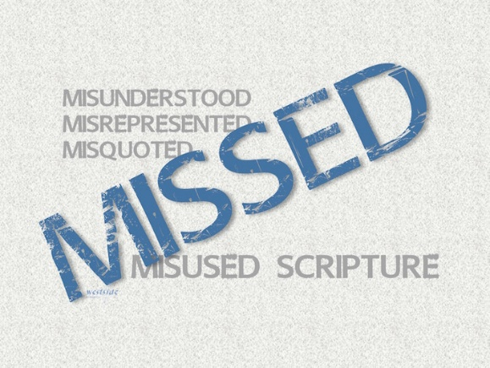
7-17-16
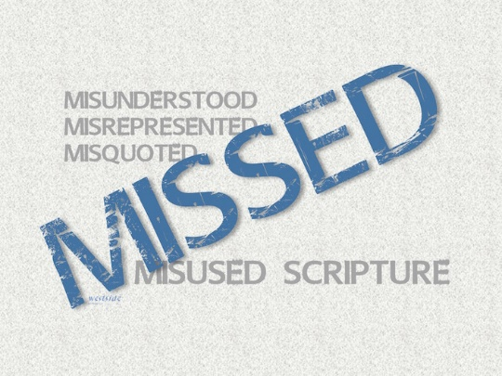
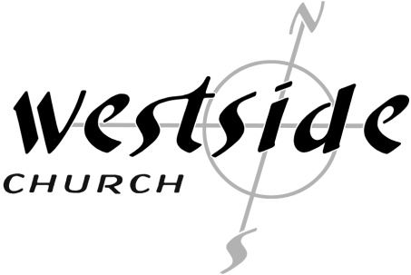

MISSED
Misunderstood
Misquoted
Misused
Scripture

Perfect Prayers and Justice

What The Bible Says

John 14:14
“Ask me for anything in my name, and I will do it!”

Exodus 21:24
“an eye for an eye, a tooth for a tooth”

1. Interpreting Scripture _______________

A. We approach God’s Word in humility

B. We read “from” the text and not “into the text”

C. We work to understand the context

D. We let scripture interpret scripture

E. We apply scripture to our lives

2. There are no ___________ ____________ for the perfect prayer.

John 14:13-14 (NLT)
¹³ You can ask for anything in my name, and I will do it, so that the Son can bring glory to the Father. ¹⁴ Yes, ask me for anything in my name, and I will do it!

Asking in His name is to pray
in a manner that is consistent with
who Jesus is,
what He taught
and all that He stands for.

3. Stay outta the __________________ business.

Exodus 21:23-25
The punishment must match the injury: a life for a life, ²⁴ an eye for an eye, a tooth for a tooth, a hand for a hand, a foot for a foot, ²⁵ a burn for a burn, a wound for a wound, a bruise for a bruise.

Matthew 5:38-39
“You have heard the law that says the punishment must match the injury: ‘An eye for an eye, and a tooth for a tooth.’ ³⁹ But I say, do not resist an evil person! If someone slaps you on the right cheek, offer the other cheek also.

By giving an enemy a drink, we're not excusing their misdeeds. We are recognizing them, forgiving them, and loving them in spite of their sins—just as Christ did for us.
Romans 12:16-21 (NLT)
¹⁶ Live in harmony with each other. Don’t be too proud to enjoy the company of ordinary people. And don’t think you know it all! ¹⁷ Never pay back evil with more evil. Do things in such a way that everyone can see you are honorable. ¹⁸ Do all that you can to live in peace with everyone. ¹⁹ Dear friends, never take revenge. Leave that to the righteous anger of God. For the Scriptures say, “I will take revenge; I will pay them back,” says the LORD. ²⁰ Instead, “If your enemies are hungry, feed them. If they are thirsty, give them something to drink. In doing this, you will heap burning coals of shame on their heads.” ²¹ Don’t let evil conquer you, but conquer evil by doing good.

Application

1. Let’s leave the justice business to _________

Luke 23:34
Jesus said, “Father, forgive them, for they don’t know what they are doing.”

2. Don’t worry about using special words to pray – God knows what you need __________________ _______ ________.

Matthew 6:7-13
“When you pray, don’t babble on and on as people of other religions do. They think their prayers are answered merely by repeating their words again and again. ⁸ Don’t be like them, for your Father knows exactly what you need even before you ask him! ⁹ Pray like this: Our Father in heaven, may your name be kept holy. ¹⁰ May your Kingdom come soon. May your will be done on earth, as it is in heaven. ¹¹ Give us today the food we need, ¹² and forgive us our sins, as we have forgiven those who sin against us. ¹³ And don’t let us yield to temptation, but rescue us from the evil one.

Response:

What is God speaking to me?

Specifically, how will I obey Him?

