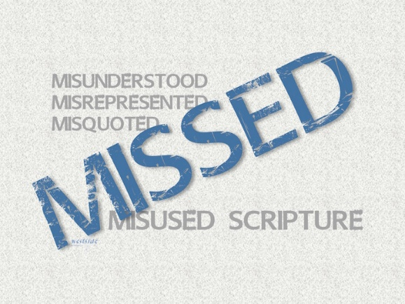
7-10-16
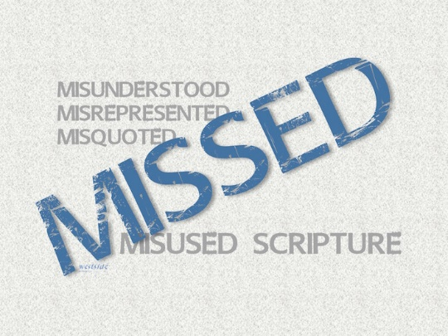

MISSED
Misunderstood
Misquoted
Misused
Scripture

First Things First

What The Bible Says

2 Chronicles 7:14
If my people who are called by my name will humble themselves and pray and seek my face and turn from their wicked ways, I will hear from heaven and will forgive their sins and restore their land.

1. Interpreting Scripture Faithfully

A. We approach God’s Word in ________________

B. We read “_____________” the text and not “_____________ the text”

C. We work to understand the ___________________

D. We let ____________________ interpret scripture

E. We _____________ scripture to our lives
Jesus’ “love language”

John 14:15
“If you love me, obey my commandments.

Matthew 7:24-27
“Anyone who listens to my teaching and follows it is wise, like a person who builds a house on solid rock. ²⁵ Though the rain comes in torrents and the floodwaters rise and the winds beat against that house, it won’t collapse because it is built on bedrock. ²⁶ But anyone who hears my teaching and ignores it is foolish, like a person who builds a house on sand. ²⁷ When the rains and floods come and the winds beat against that house, it will collapse with a mighty crash.”

James 1:25
But if you look carefully into the perfect law that sets you free, and if you do what it says and don’t forget what you heard, then God will bless you for doing it.

2. God _____________________ us to be good citizens, pay our taxes, and pray for our leaders . . .

Romans 13:1-6
Everyone must submit to governing authorities. For all authority comes from God, and those in positions of authority have been placed there by God. ² So anyone who rebels against authority is rebelling against what God has instituted, and they will be punished. ³ For the authorities do not strike fear in people who are doing right, but in those who are doing wrong. Would you like to live without fear of the authorities? Do what is right, and they will honor you. ⁴ The authorities are God’s servants, sent for your good. But if you are doing wrong, of course you should be afraid, for they have the power to punish you. They are God’s servants, sent for the very purpose of punishing those who do what is wrong. ⁵ So you must submit to them, not only to avoid punishment, but also to keep a clear conscience. ⁶ Pay your taxes, too, for these same reasons. For government workers need to be paid. They are serving God in what they do.

Matthew 22:15-22
Then the Pharisees met together to plot how to trap Jesus into saying something for which he could be arrested. ¹⁶ They sent some of their disciples, along with the supporters of Herod, to meet with him. “Teacher,” they said, “we know how honest you are. You teach the way of God truthfully. You are impartial and don’t play favorites. ¹⁷ Now tell us what you think about this: Is it right to pay taxes to Caesar or not?” ¹⁸ But Jesus knew their evil motives. “You hypocrites!” he said. “Why are you trying to trap me? ¹⁹ Here, show me the coin used for the tax.” When they handed him a Roman coin, ²⁰ he asked, “Whose picture and title are stamped on it?” ²¹ “Caesar’s,” they replied. “Well, then,” he said, “give to Caesar what belongs to Caesar, and give to God what belongs to God.” ²² His reply amazed them, and they went away.

3. ... but, God also expects that we place a higher priority on our citizenship in _________ __________________.

Matthew 6:25-34
I tell you not to worry about everyday life—whether you have enough food and drink, or enough clothes to wear. Isn’t life more than food, and your body more than clothing? ²⁶ Look at the birds. They don’t plant or harvest or store food in barns, for your heavenly Father feeds them. And aren’t you far more valuable to him than they are? ²⁷ Can all your worries add a single moment to your life? ²⁸ “And why worry about your clothing? Look at the lilies of the field and how they grow. They don’t work or make their clothing, ²⁹ yet Solomon in all his glory was not dressed as beautifully as they are. ³⁰ And if God cares so wonderfully for wildflowers that are here today and thrown into the fire tomorrow, he will certainly care for you. Why do you have so little faith? ³¹ “So don’t worry about these things, saying, ‘What will we eat? What will we drink? What will we wear?’ ³² These things dominate the thoughts of unbelievers, but your heavenly Father already knows all your needs. ³³ Seek the Kingdom of God above all else, and live righteously, and he will give you everything you need. ³⁴ “So don’t worry about tomorrow, for tomorrow will bring its own worries. Today’s trouble is enough for today.

Application

1. We _________live in two worlds at one time!

God has put eternity in my heart
so I live in this present world
with my sights set on His Kingdom . . .
on earth as it is in heaven!!

2. I _______ be a good citizen of this earth AND of heaven!

“Citizens of heaven and residents of earth”

Micah 6:8 (NKJV)
He has shown you, O man, what is good; And what does the LORD require of you; But to do justly, To love mercy, And to walk humbly with your God

3. Do not _____________

Philippians 4:4-9
Always be full of joy in the Lord. I say it again—rejoice! ⁵ Let everyone see that you are considerate in all you do. Remember, the Lord is coming soon. ⁶ Don’t worry about anything; instead, pray about everything. Tell God what you need, and thank him for all he has done. ⁷ Then you will experience God’s peace, which exceeds anything we can understand. His peace will guard your hearts and minds as you live in Christ Jesus. ⁸ And now, dear brothers and sisters, one final thing. Fix your thoughts on what is true, and honorable, and right, and pure, and lovely, and admirable. Think about things that are excellent and worthy of praise. ⁹ Keep putting into practice all you learned and received from me—everything you heard from me and saw me doing. Then the God of peace will be with you.

Response:

What is God speaking to me?

Specifically, how will I obey Him?

