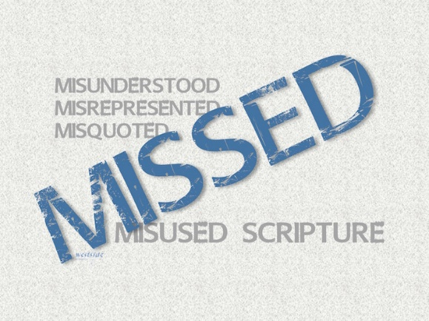
7-3-16
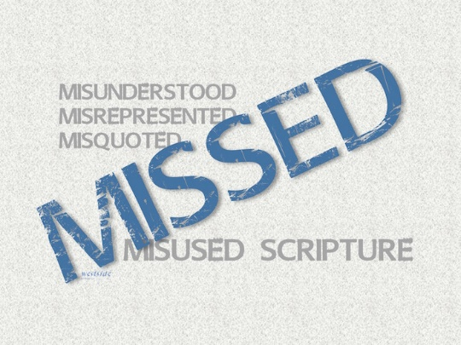

MISSED
Misunderstood
Misquoted
Misused
Scripture
TRAIN ‘em UP!

- True Freedom

Psalm 119:44-45 (NLT)
⁴⁴ I will keep on obeying your instructions forever and ever. ⁴⁵ I will walk in freedom, for I have devoted myself to your commandments.

We have to interpret the Bible in context with the whole Word of God through the influential power of the Spirit of truth, despite what the fallen world might say and desire.

- Proverbs 22:6 (ESV)
Train up a child in the way he should go; even when he is old he will not depart from it.

- What it is _____ saying
- ____________ is OK
- I don’t believe it is ________ adult children’s poor ________ on their parents either

John 9:1-7
Romans 11:33-36

Let’s face it Adam and Eve went wayward and they have the perfect Dad

- But it is __________
- _______ your Children

- _____________ is serious ___________
  - We need to be ___________ for
    - ______________
    - Guidance
    - _______
    - Their ____________

Ephesians 6:4 (NLT) ⁴ Fathers, do not provoke your children to anger by the way you treat them. Rather, bring them up with the discipline and instruction that comes from the Lord.

Deuteronomy 6:6-7 (ESV)
⁶ And these words that I command you today shall be on your heart. ⁷ You shall teach them diligently to your children, and shall talk of them when you sit in your house, and when you walk by the way, and when you lie down, and when you rise.

- Train means to ___________, Prepare for _________, _______
- Dedicated to _________
- Push a kid to their ______, to the _______ _______ God has for them

Psalm 127:3-5

- What it takes to be a _________. How do we win their _________?

- Hard work, _____________, devotion, ____________, consistency
- Don’t be afraid to ___________

Proverbs 13:24 (ESV)
²⁴ Whoever spares the rod hates his son, but he who loves him is diligent to discipline him.

- Be a ________________ example of Christ.

1 Corinthians 10:31-33 (ESV)
³¹ So, whether you eat or drink, or whatever you do, do all to the glory of God. ³² Give no offense to Jews or to Greeks or to the church of God, ³³ just as I try to please everyone in everything I do, not seeking my own advantage, but that of many, that they may be saved.

- Freedom is… _______________

John 8:31-32 (ESV)
³¹ So Jesus said to the Jews who had believed him, “If you abide in my word, you are truly my disciples,³² and you will know the truth, and the truth will set you free.”

Home = Joy, Peace, Freedom, Excitement

If you have blown it, then Reconcile it

Teach them to abide in truth

Your children need to know Jesus as their Lord and Savior!

