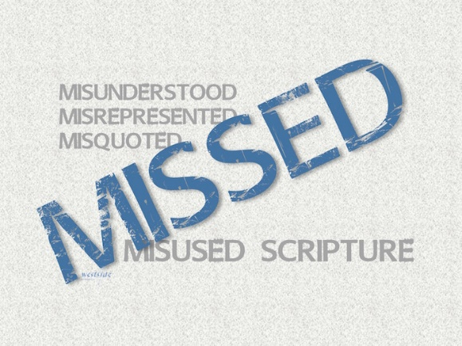
6-19-16
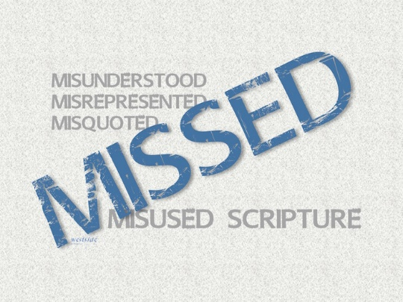

MISSED
Misunderstood
Misquoted
Misused
Scripture
Money Money Money
“is the root of all evil”
Part 2

MISSED Series:

Interpreting Scripture Faithfully

A. We approach God’s Word in humility
B. We read “from” the text and not “into the text”
C. We work to understand the context
D. We let scripture interpret scripture
E. We apply scripture to our lives

1 Timothy 6:10 (ESV)
For the love of money is A root of all kinds of evils. It is through this craving that some have wandered away from the faith and pierced themselves with many pangs.

What The Bible Says

2 Corinthians 9:6-12
Remember this—a farmer who plants only a few seeds will get a small crop. But the one who plants generously will get a generous crop. ⁷ You must each decide in your heart how much to give. And don’t give reluctantly or in response to pressure. “For God loves a person who gives cheerfully.” ⁸ And God will generously provide all you need. Then you will always have everything you need and plenty left over to share with others. ⁹ As the Scriptures say, “They share freely and give generously to the poor. Their good deeds will be remembered forever.” ¹⁰ For God is the one who provides seed for the farmer and then bread to eat. In the same way, he will provide and increase your resources and then produce a great harvest of generosity in you. ¹¹ Yes, you will be enriched in every way so that you can always be generous. And when we take your gifts to those who need them, they will thank God. ¹² So two good things will result from this ministry of giving—the needs of the believers in Jerusalem will be met, and they will joyfully express their thanks to God.
In the early church:

1. ___________________________ Belongs to God

Psalm 24:1
The earth is the Lord's, and everything in it,
the world, and all who live in it;

2. The Tithe

Malachi 3:10-11 (ESV)
Bring the full tithe into the storehouse, that there may be food in my house. And thereby put me to the test, says the LORD of hosts, if I will not open the windows of heaven for you and pour down for you a blessing until there is no more need. ¹¹ I will rebuke the devourer for you, so that it will not destroy the fruits of your soil, and your vine in the field shall not fail to bear, says the LORD of hosts.

3. God’s Challenge To Us
- prove me now

4. Offerings

Luke 6:38
Give, and you will receive. Your gift will return to you in full—pressed down, shaken together to make room for more, running over, and poured into your lap. The amount you give will determine the amount you get back.” (also mercy , forgiveness, & judging)

What Has God Given To Us ?

“You cannot out give God”

Who To Give To:

The __________________:
Matthew 23:23 (NLT)
"How terrible it will be for you teachers of religious law and you Pharisees. Hypocrites! For you are careful to tithe even the tiniest part of your income, but you ignore the important things of the law—justice, mercy, and faith. You should tithe, yes, but you should not leave undone the more important things.

Winston Churchill:
“We make a living by what we get, but we
make a life by what we give.”

__________________________ Asks:

Matthew 5:42 (NIV)
Give to the one who asks you, and do not turn away from the one who wants to borrow from you.

Luke 6:30 (NIV)
Give to everyone who asks you, and if anyone takes what belongs to you, do not demand it back.

The _______________________:

Matthew 6:2
When you give to someone in need, don’t do as the hypocrites do—blowing trumpets in the synagogues and streets to call attention to their acts of charity . . .

Proverbs 11:25
A generous man will prosper; he who refreshes others will himself be refreshed.

The ______________________________:

Matthew 10:42 (NIV)
And if anyone gives even a cup of cold water to one of these little ones because he is my disciple, I tell you the truth, he will certainly not lose his reward."

The ____________________________:

Matthew 22:21 (NIV)
Then he said to them, "Give to Caesar what is Caesar's, and to God what is God's."

The __________________:
Mark 10:21 (NIV)
Jesus looked at him and loved him. "One thing you lack," he said. "Go, sell everything you have and give to the poor, and you will have treasure in heaven. Then come, follow me."

Luke 12:33 (NIV)
Sell your possessions and give to the poor. Provide purses for yourselves that will not wear out, a treasure in heaven that will not be exhausted, where no thief comes near and no moth destroys.

“My” (_____________________) Followers:

Luke 9:13 (NIV)
He replied, "You give them something to eat."

How Do We Give?

As A _____________________:
Luke 16:10-13 (NIV)
"Whoever can be trusted with very little can also be trusted with much, and whoever is dishonest with very little will also be dishonest with much. [11] So if you have not been trustworthy in handling worldly wealth, who will trust you with true riches? [12] And if you have not been trustworthy with someone else's property, who will give you property of your own?
[13] "No servant can serve two masters. Either he will hate the one and love the other, or he will be devoted to the one and despise the other. You cannot serve both God and Money."

“All ________”

Luke 14:33 (NIV)
In the same way, any of you who does not give up everything he has cannot be my disciple.

With ______________________:

Luke 19:8 (NIV)
But Zacchaeus stood up and said to the Lord, "Look, Lord! Here and now I give half of my possessions to the poor, and if I have cheated anybody out of anything, I will pay back four times the amount."

With ____________________ Motives:

Mark 12:41-44
Jesus sat down near the collection box in the Temple and watched as the crowds dropped in their money. Many rich people put in large amounts. ⁴² Then a poor widow came and dropped in two small coins. ⁴³ Jesus called his disciples to him and said, “I tell you the truth, this poor widow has given more than all the others who are making contributions. ⁴⁴ For they gave a tiny part of their surplus, but she, poor as she is, has given everything she had to live on.”

Law versus Grace
Old Covenant vs New Covenant
actions vs attitude

Application:

What is God speaking to me?

Specifically, how will I obey Him?

