5-1-16
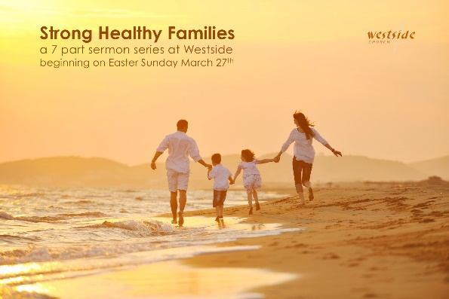

Strong Healthy Families
Are Preparing For The Future

1. The Great Commission requires that we make _______________

Matthew 28:19-20 (ESV)
Go therefore and make disciples of all nations, baptizing them in the name of the Father and of the Son and of the Holy Spirit, ²⁰ teaching them to observe all that I have commanded you. And behold, I am with you always, to the end of the age.”

True discipleship cannot begin until we learn one important key aspect of life:
. . . there is one God and we are not it!

Joshua 1:8 (NKJV)
This Book of the Law shall not depart from your mouth, but you shall meditate in it day and night, that you may observe to do according to all that is written in it. For then you will make your way prosperous, and then you will have good success.

Parents:
“Your first and most important disciples
are your children”

2. However, each person must _________ _______ to follow Jesus

Judges 2:10 (ESV)
¹⁰ And all that generation also were gathered to their fathers. And there arose another generation after them who did not know the LORD or the work that he had done for Israel.

1st Gen Knows God Knows His Works
2nd Gen Knows God Knows about His Works
3rd Gen Knows about God Knows about His Works

Moralistic Therapeutic Deism
“If I do good – I’ll feel good”

3. So we must all participate in ____________ ___ _______ for the coming generations to follow Jesus

“parenting is the greatest trend that influences
change in behaviors across generations”
-Jason Dorsey TEDx Houston

Deuteronomy 4:9 “But watch out! Be careful never to forget what you yourself have seen. Do not let these memories escape from your mind as long as you live! And be sure to pass them on to your children and grandchildren.

Application

How am ___ _______________ to make it possible for the next generation to follow Jesus?

- am I all in?
- is my life consistent?
- am I an example?

Parenting is a mandate from the Lord.
- We are to
  - ________________ them God’s truth,
  - ________________ dependence on Him,
  - ________________ them in righteousness and
  - ________________ their disobedience

Best advice: Be the Parent!

“Parents: Please do not punish your teens by keeping them away from church and church events possibly denying them the very thing that could help them the most. The impact of God’s Word and the gathering of God’s people has a profound and eternal impact which may be just what’s needed during this time in their lives.”
-sb

Deuteronomy 6:1-3
“These are the commands, decrees, and regulations that the LORD your God commanded me to teach you. You must obey them in the land you are about to enter and occupy, ² and you and your children and grandchildren must fear the LORD your God as long as you live. If you obey all his decrees and commands, you will enjoy a long life. ³ Listen closely, Israel, and be careful to obey. Then all will go well with you, and you will have many children in the land flowing with milk and honey, just as the LORD, the God of your ancestors, promised you.

Response:

What is God speaking to me?

Specifically, how will I obey Him?

