4-24-16
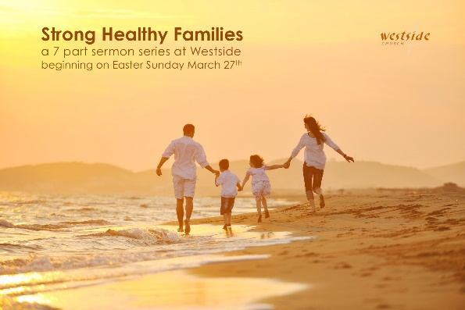

Strong Healthy Families
Are Walking in Unity

1. ___________________ In Unity

Psalm 133:1-3
How wonderful and pleasant it is when brothers live together in harmony . . . there the LORD has pronounced his blessing, even life everlasting.

2. The Two Shall Become __________

Genesis 2:18-25 (ESV)
¹⁸ Then the LORD God said, “It is not good that the man should be alone; I will make him a helper fit for him.” ¹⁹ Now out of the ground the LORD God had formed every beast of the field and every bird of the heavens and brought them to the man to see what he would call them. And whatever the man called every living creature, that was its name. ²⁰ The man gave names to all livestock and to the birds of the heavens and to every beast of the field. But for Adam there was not found a helper fit for him. ²¹ So the LORD God caused a deep sleep to fall upon the man, and while he slept took one of his ribs and closed up its place with flesh. ²² And the rib that the LORD God had taken from the man he made into a woman and brought her to the man. ²³ Then the man said, “This at last is bone of my bones and flesh of my flesh; she shall be called Woman, because she was taken out of Man.” ²⁴ Therefore a man shall leave his father and his mother and hold fast to his wife, and they shall become one flesh. ²⁵ And the man and his wife were both naked and were not ashamed.

Marriage in the Bible?

1. Sexual Union?

2. “Legally Married” only?

3. Legally AND “Before God”?

As Christians, it is important to focus on the true purpose of
marriage when considering the wedding ceremony.

The details are not what's important, but rather, the
couple's covenant commitment before God and men.

3. United In The _________________

Ephesians 4:1-6
Therefore I, a prisoner for serving the Lord, beg you to lead a life worthy of your calling, for you have been called by God. ² Always be humble and gentle. Be patient with each other, making allowance for each other’s faults because of your love. ³ Make every effort to keep yourselves united in the Spirit, binding yourselves together with peace. ⁴ For there is one body and one Spirit, just as you have been called to one glorious hope for the future. ⁵ There is one Lord, one faith, one baptism, ⁶ and one God and Father, who is over all and in all and living through all.

Application

1. Building unity in our _____________

Matthew 18:19-20
“I also tell you this: If two of you agree here on earth concerning anything you ask, my Father in heaven will do it for you. ²⁰ For where two or three gather together as my followers, I am there among them.”

How about starting by eating dinner together?

stats/ideas:

2. Building unity in our ____________________

marriage is not a 50-50 proposition . . . it’s 100%-100%

his main job: love her
her main job: respect him

#1 PRAY TOGETHER EVERY DAY

3. Building unity in our _______________

Philippians 2:1-6
Is there any encouragement from belonging to Christ? Any comfort from his love? Any fellowship together in the Spirit? Are your hearts tender and compassionate? ² Then make me truly happy by agreeing wholeheartedly with each other, loving one another, and working together with one mind and purpose. ³ Don’t be selfish; don’t try to impress others. Be humble, thinking of others as better than yourselves. ⁴ Don’t look out only for your own interests, but take an interest in others, too. ⁵ You must have the same attitude that Christ Jesus had. ⁶ Though he was God, he did not think of equality with God as something to cling to.

Colossians 3:12-15
Since God chose you to be the holy people he loves, you must clothe yourselves with tenderhearted mercy, kindness, humility, gentleness, and patience. ¹³ Make allowance for each other’s faults, and forgive anyone who offends you. Remember, the Lord forgave you, so you must forgive others. ¹⁴ Above all, clothe yourselves with love, which binds us all together in perfect harmony. ¹⁵ And let the peace that comes from Christ rule in your hearts. For as members of one body you are called to live in peace. And always be thankful.

Response:

What is God speaking to me?

Specifically, how will I obey Him?

