4-17-16
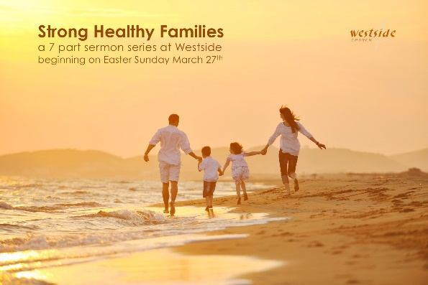
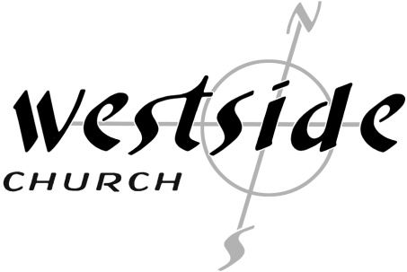

Previously:
Strong Healthy Families:
- Are Made of Strong Healthy Individuals
- Are Looking Forward
- Are Whole: emotionally-physically-spiritually

This Week:
Strong Healthy Families:
Are Walking In Freedom

Opening Comments
John 8:36 (NLT)
³⁶ So if the Son sets you free, you are truly free. SET FREE!

What The Bible Says

Galatians 5:1-6 (NLT)
¹ So Christ has truly set us free. (Galatians 5:1 (NASB) ¹ It was for freedom that Christ set us free) Now make sure that you stay free, and don’t get tied up again in slavery to the law.
² Listen! I, Paul, tell you this: If you are counting on circumcision to make you right with God, then Christ will be of no benefit to you.
³ I’ll say it again. If you are trying to find favor with God by being circumcised, you must obey every regulation in the whole law of Moses.
⁴ For if you are trying to make yourselves right with God by keeping the law, you have been cut off from Christ! You have fallen away from God’s grace.
⁵ But we who live by the Spirit eagerly wait to receive by faith the righteousness God has promised to us.
⁶ For when we place our faith in Christ Jesus, there is no benefit in being circumcised or being uncircumcised. What is important is faith expressing itself in love.

Galatians 5:13-26 (NLT)
¹³ For you have been called to live in freedom, my brothers and sisters. But don’t use your freedom to satisfy your sinful nature. Instead, use your freedom to serve one another in love.
¹⁴ For the whole law can be summed up in this one command: “Love your neighbor as yourself.”
¹⁵ But if you are always biting and devouring one another, watch out! Beware of destroying one another.
¹⁶ So I say, let the Holy Spirit guide your lives. Then you won’t be doing what your sinful nature craves.
¹⁷ The sinful nature wants to do evil, which is just the opposite of what the Spirit wants. And the Spirit gives us desires that are the opposite of what the sinful nature desires. These two forces are constantly fighting each other, so you are not free to carry out your good intentions.
¹⁸ But when you are directed by the Spirit, you are not under obligation to the law of Moses.
¹⁹ When you follow the desires of your sinful nature, the results are very clear: sexual immorality, impurity, lustful pleasures,
²⁰ idolatry, sorcery, hostility, quarreling, jealousy, outbursts of anger, selfish ambition, dissension, division,
²¹ envy, drunkenness, wild parties, and other sins like these. Let me tell you again, as I have before, that anyone living that sort of life will not inherit the Kingdom of God.
²² But the Holy Spirit produces this kind of fruit in our lives: love, joy, peace, patience, kindness, goodness, faithfulness,
²³ gentleness, and self-control. There is no law against these things!
²⁴ Those who belong to Christ Jesus have nailed the passions and desires of their sinful nature to his cross and crucified them there.
²⁵ Since we are living by the Spirit, let us follow the Spirit’s leading in every part of our lives.
²⁶ Let us not become conceited, or provoke one another, or be jealous of one another.

1. Freedom from ___________________

Galatians 5:1-6 (NLT)
¹ So Christ has truly set us free. Now make sure that you stay free, and don’t get tied up again in slavery to the law.

2. ________________________ Freedom

Proverbs 22:7 (ESV)
⁷ The rich rules over the poor, and the borrower is the slave of the lender.

3. ________________________ Freedom

Ephesians 4:31-32 (NLT)
³¹ Get rid of all bitterness, rage, anger, harsh words, and slander, as well as all types of evil behavior. ³² Instead, be kind to each other, tenderhearted, forgiving one another, just as God through Christ has forgiven you.

Matthew 18:21-22 (NLT)
²¹ Then Peter came to him and asked, “Lord, how often should I forgive someone who sins against me? Seven times?” ²² “No, not seven times,” Jesus replied, “but seventy times seven! (can go on to parable of King and servant forgiving debt)

Matthew 6:14-15 (NLT)
¹⁴ “If you forgive those who sin against you, your heavenly Father will forgive you. ¹⁵ But if you refuse to forgive others, your Father will not forgive your sins.

Application

- God wants His people ____________

Galatians 5:1 (NASB) ¹ It was for freedom that Christ set us free

No longer _______________ by the chains of sin and death.

- God wants his people free

So that we can become who _____ ________________ us to be.

Galatians 5:16
¹⁶ So I say, let the Holy Spirit guide your lives. Then you won’t be doing what your sinful nature craves.

²² But the Holy Spirit produces this kind of fruit in our lives: love, joy, peace, patience, kindness, goodness, faithfulness,
²³ gentleness, and self-control. There is no law against these things!

- God wants his people free.

So that we can ______ what He has called us to.

¹³ For you have been called to live in freedom, my brothers and sisters. But don’t use your freedom to satisfy your sinful nature. Instead, use your freedom to serve one another in love.
¹⁴ For the whole law can be summed up in this one command: “Love your neighbor as yourself.”

Response:

What is God speaking to me?

Specifically, how will I obey Him?

