11-19-17
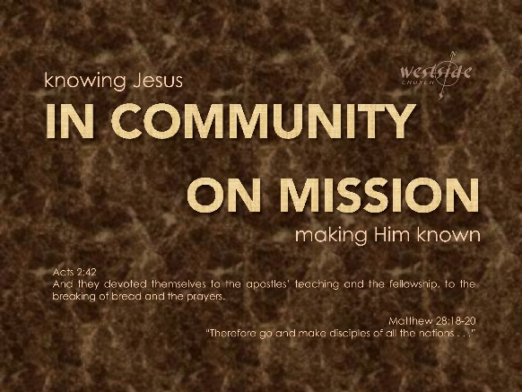

IC-OM #11

Early Church Characteristics
#2 Holy Spirit Power

“What comes into our minds when we think about God is the most important thing about us.”
A. W. Tozer

1. Community (last week)

2. Holy Spirit Power

“What is possibly most needed is the presence of God in the midst of His people. . . . Without the presence of God, we have no power, no authority, no transformation and no glory to display to the nations. . . . Without the Spirit that gives life we have only the letter of the law to preach. Without the Spirit there is death, but when He comes there is life and with the life there is the potential for growth and fruitfulness. Genuine ministry takes place when there is an operation of the Holy Spirit, whereby He transforms us into the image of Christ through the Word of God. If this transformation does not happen, then no ministry has taken place.”

from Building on Apostolic Foundations by Dudley Daniel

"Nothing we ever do will have any eternal impact
without His Power and Presence working among us."
-sb

What The Bible Says:

Acts 1:4-5
Once when he was eating with them, he commanded them, “Do not leave Jerusalem until the Father sends you the gift he promised, as I told you before. ⁵ John baptized with water, but in just a few days you will be baptized with the Holy Spirit.”

Acts 2:1-13
On the day of Pentecost all the believers (how many?) were meeting together in one place. ² Suddenly, there was a sound from heaven like the roaring of a mighty windstorm, and it filled the house where they were sitting. ³ Then, what looked like flames or tongues of fire appeared and settled on each of them. ⁴ And everyone present was filled with the Holy Spirit and began speaking in other languages, as the Holy Spirit gave them this ability. ⁵ At that time there were devout Jews from every nation living in Jerusalem. ⁶ When they heard the loud noise, everyone came running, and they were bewildered to hear their own languages being spoken by the believers. ⁷ They were completely amazed. “How can this be?” they exclaimed. “These people are all from Galilee, ⁸ and yet we hear them speaking in our own native languages! ⁹ Here we are—Parthians, Medes, Elamites, people from Mesopotamia, Judea, Cappadocia, Pontus, the province of Asia, ¹⁰ Phrygia, Pamphylia, Egypt, and the areas of Libya around Cyrene, visitors from Rome (both Jews and converts to Judaism), ¹¹ Cretans, and Arabs. And we all hear these people speaking in our own languages about the wonderful things God has done!” ¹² They stood there amazed and perplexed. “What can this mean?” they asked each other. ¹³ But others in the crowd ridiculed them, saying, “They’re just drunk, that’s all!”

1. Don’t _____________ When There Doesn’t Seem To Be Anything Happening

¹ On the day of Pentecost all the believers were meeting together in one place.

Galatians 6:9
So let’s not get tired of doing what is good. At just the right time we will reap a harvest of blessing if we don’t give up.

2. God Doesn’t Have To Ask Our _________________ When He Decides To Act

² Suddenly, there was a sound from heaven like the roaring of a mighty windstorm

Romans 9:21 (MSG)
Isn't it obvious that a potter has a perfect right to shape one lump of clay into a vase for holding flowers and another into a pot for cooking beans?

Psalm 50:21 (NASB)
. . . You thought that I was just like you . . .

3. Don’t _____________________ On What God Is Doing

³ Then, what looked like flames or tongues of fire appeared and settled on each of them. ⁴ And everyone present was filled with the Holy Spirit

“Find out what God is doing –
and jump in with both feet.”

4. When God Does Stuff – People _____________

⁶ When they heard the loud noise, everyone came running

Colossians 4:5-6
Live wisely among those who are not believers, and make the most of every opportunity. ⁶ Let your conversation be gracious and attractive so that you will have the right response for everyone.

5. Don’t Put God In A ___________

⁷ They were completely amazed. “How can this be?” they exclaimed.

Therefore:

6. Everything We Do Should Bring ______________ To God

¹¹ . . . we all hear these people speaking in our own languages about the wonderful things God has done!”

“Any work of God on our behalf should result in our returning all praise and glory and honor back to Him!”
-sb

Now What?

Results of the Presence of God and His Holy Spirit’s power working in us:

1. We become more effective ________________.

Acts 1:8
But you will receive power when the Holy Spirit comes on you; and you will be my witnesses in Jerusalem, and in all Judea and Samaria, and to the ends of the earth."

1 Cor. 12:3
Therefore I tell you that no one who is speaking by the Spirit of God says, "Jesus be cursed," and no one can say, "Jesus is Lord," except by the Holy Spirit.

2. We see more signs, wonders, ______________.

Acts 6:8
And Stephen, full of grace and power, was performing great wonders and signs among the people.

3. We receive power to ______________ – no matter what challenges we face.

“I believe that the number one sign that a person is filled with the Holy Spirit is that they live a victorious life.”
-sb

4. We see that the fullness of His Spirit is a prerequisite for ________________.

Acts 6:3
Brothers, choose seven men from among you who are known to be full of the Spirit and wisdom. We will turn this responsibility over to them

“If there’s anything in your life bigger
than your desire to be a Spirit-filled Christian
then you’ll never be a Spirit-filled Christian.”
A.W. Tozer

5. We live in _________________ and not legalism.

Romans 8:2
because through Christ Jesus the law of the Spirit of life set me free from the law of sin and death.

Luke 4:18 (NIV)
"The Spirit of the Lord is on me,
because he has anointed me
to preach good news to the poor.
He has sent me to proclaim freedom for the prisoners
and recovery of sight for the blind,
to release the oppressed,

2 Cor. 3:17 (NIV)
Now the Lord is the Spirit, and where the Spirit of the Lord is, there is freedom.

6. We see the Gifts of the Spirit operating in every aspect of our lives:

- __________________
- __________________
- __________________

Response:

What is God speaking to me?

Specifically, how will I obey Him?

