10-22-17

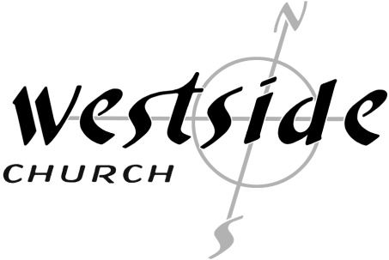

IN-OM #7
The Good Work Within You
Authentic New Testament Church

Benefits of Church Attendance

1. Significantly Lower Risk of _________________:

2. Better ___________ and _____________ Management

3. Better ____________ / higher education prospects –

4. Significantly Lower Risk of _______________ / Longer life expectancy:

5. Enhanced Intimacy in _________________ (Better sex lives)

The top two predictors of spiritual growth are:

1. How many close _____________ friends do you have at any given moment

2. Do you have “_______________” in a weekly ministry that charges you up?

Group/Gallup study: people who attend churches without deep friendships and ministry opportunities (IN COMMUNITY-ON MISSION) tended to express much higher dissatisfaction in both their church and their relationship with God.

Westside’s Vision: A Strong Healthy Local Church

On our website:
We Value The Church – Christ’s Body And Bride

The New Testament pattern shows us that Jesus is the Head of the Church. We also see in scripture that a team of elders (pastors) is the highest human authority leading the local church. At the same time we will actively maintain a close partnership with an outside team of seasoned men and women of God and invite them in to bring truth, correction and accountability. This is neither a denomination nor total independence on the local church’s part – it is simply the pattern we see in God’s Word. We (the church) will walk in humility, honesty, purity, integrity, while living in genuine freedom without legalism or excesses.

Colossians 1:18, I Peter 5:1-3, Acts 20,
Philippians 4:10-20, Titus 1:5, Galatians 5:1 & 13

What The Bible Says:

Philippians 1:1-6
This letter is from Paul and Timothy, slaves of Christ Jesus. I am writing to all of God’s holy people in Philippi who belong to Christ Jesus, including the elders and deacons. ² May God our Father and the Lord Jesus Christ give you grace and peace. ³ Every time I think of you, I give thanks to my God. ⁴ Whenever I pray, I make my requests for all of you with joy, ⁵ for you have been my partners in spreading the Good News about Christ from the time you first heard it until now. ⁶ And I am certain that God, who began the good work within you, will continue his work until it is finally finished on the day when Christ Jesus returns.

1. Signs of a healthy local church in the New Testament

1. Changed Lives:
“Paul”

2. New Converts:
“Timothy”

3. Team:
“Paul AND Timothy”

4. Servants
“slaves” (doulos)

5. Saints:
“___________ Holy __________”

6. The Local Church:
“Philippi”

7. Disciples:
“_____________ to Jesus Christ”

8. Pastors/Overseers:
“Elders”

9. Leaders:
“Deacons”

10. Community:
Elders AND Deacons AND ______________

11. The Favor and Generosity of God:
“May God . . . give you grace and ______________”

12. Prayer: “I pray”

13. Prayerful, sacrificially joy-filled oversight:
“Whenever I pray, I make my requests for all of you with _________”

14. The Apostolic:
“________________ In The Gospel”

15. The Gospel:
“spreading the Good News”

16. Faithfulness:
“from the time”

17. Justification:
“__________ the good work in you”

18. Sanctification:
“will ________________ His work”

19. Glorification:
“until it is finally finished on the day when Christ Jesus ____________”

Now What?

Our Vision:
“Becoming a Strong – Healthy – Local – Church”

1. We were created for _________________

2. We were created for a ______________

Hebrews 10:23-25
Let us hold tightly without wavering to the hope we affirm, for God can be trusted to keep his promise. ²⁴ Let us think of ways to motivate one another to acts of love and good works. ²⁵ And let us not neglect our meeting together, as some people do, but encourage one another, especially now that the day of his return is drawing near.

Response:

What is God speaking to me?

Specifically, how will I obey Him?

