2-14-16
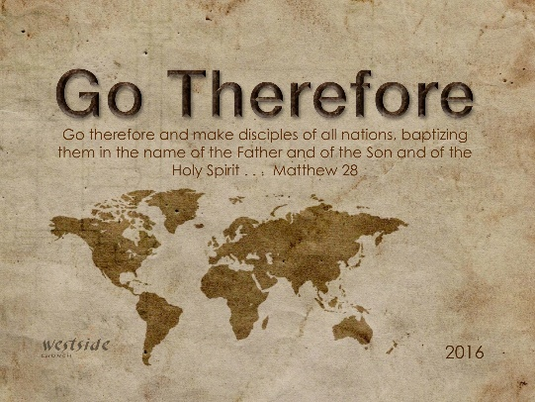

THE GO FOR ALL OF THE SANTS!!!!!

1. Mark 16:15 (ESV)
¹⁵ And he said to them, “Go into all the world and proclaim the gospel to the whole creation.

Mark 16:15 (NIV2011)
¹⁵ He said to them, “Go into all the world and preach the gospel to all creation.

Mark 16:15 (NLT)
¹⁵ And then he told them, “Go into all the world and preach the Good News to everyone.

Mark 16:15 (MSG)
¹⁵ Then he said, "Go into the world. Go everywhere and announce the Message of God's good news to one and all.

2. But …

Ephesians 6:10-19 (ESV) (get back to the armor for war)
¹⁰ Finally, be strong in the Lord and in the strength of his might. ¹¹ Put on the whole armor of God, that you may be able to stand against the schemes of the devil. ¹² For we do not wrestle against flesh and blood, but against the rulers, against the authorities, against the cosmic powers over this present darkness, against the spiritual forces of evil in the heavenly places. ¹³ Therefore take up the whole armor of God, that you may be able to withstand in the evil day, and having done all, to stand firm. ¹⁴ Stand therefore, having fastened on the belt of truth, and having put on the breastplate of righteousness, ¹⁵ and, as shoes for your feet, having put on the readiness given by the gospel of peace. ¹⁶ In all circumstances take up the shield of faith, with which you can extinguish all the flaming darts of the evil one; ¹⁷ and take the helmet of salvation, and the sword of the Spirit, which is the word of God, ¹⁸ praying at all times in the Spirit, with all prayer and supplication. To that end keep alert with all perseverance, making supplication for all the saints, ¹⁹ and also for me, that words may be given to me in opening my mouth boldly to proclaim the mystery of the gospel,
Feelings….

1 Corinthians 2:1-5 (ESV)
¹ And I, when I came to you, brothers, did not come proclaiming to you the testimony of God with lofty speech or wisdom. ² For I decided to know nothing among you except Jesus Christ and him crucified. ³ And I was with you in weakness and in fear and much trembling, ⁴ and my speech and my message were not in plausible words of wisdom, but in demonstration of the Spirit and of power, ⁵ so that your faith might not rest in the wisdom of men but in the power of God.

So let’s war!!! OUR ARMOR

- Belt of Truth (Gospel Message you have heard)

- Breastplate of Righteousness (living obediently)

- Shield of Faith (Confidence of belief)

- Helmet of Salvation (Know who you are)

- Sword of the Spirit (Word of God)

3. Our Motivation

Breakdown it down

Pray for one person

