1-24-16
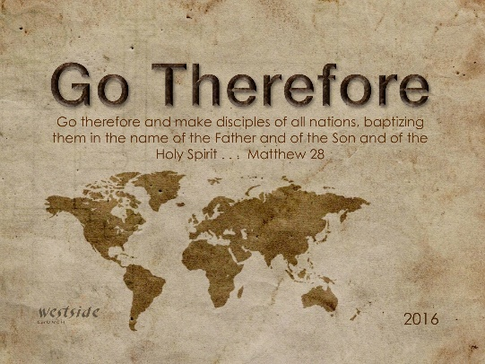

Leave

Genesis 12:1-5
The LORD had said to Abram, “Go from your country, your people and your father’s household to the land I will show you. ² “I will make you into a great nation, and I will bless you; I will make your name great, and you will be a blessing. ³ I will bless those who bless you, and whoever curses you I will curse; and all peoples on earth will be blessed through you.” ⁴ So Abram went, as the LORD had told him; and Lot went with him. Abram was seventy-five years old when he set out from Harran. ⁵ He took his wife Sarai, his nephew Lot, all the possessions they had accumulated and the people they had acquired in Harran, and they set out for the land of Canaan, and they arrived there.

1. Leave Your _________________

Leave: In priority, in our thinking, in our loyalty (as compared to the Kingdom of God)

Matthew 28:18-20 (NLT)
Jesus came and told his disciples, "I have been given complete authority in heaven and on earth. [19] Therefore, go and make disciples of all the nations, baptizing them in the name of the Father and the Son and the Holy Spirit. [20] Teach these new disciples to obey all the commands I have given you. And be sure of this: I am with you always, even to the end of the age."

2. Leave Your ________________

Advancing the Kingdom requires people who will give up everything including their country, their people, and their family. It’s difficult – but doable because . . .

. . . how can they believe in him if they have never heard about him? And how can they hear about him unless someone tells them? ¹⁵ And how will anyone go and tell them without being sent? That is why the Scriptures say, “How beautiful are the feet of those who bring good news!” Rom 10:14-15

"The true greatness of any church is not how many it seats but how many it sends!"
-sos

3. Leave Your __________________

Matthew 12:46-50 (MSG)
While he was still talking to the crowd, his mother and brothers showed up. They were outside trying to get a message to him. ⁴⁷ Someone told Jesus, "Your mother and brothers are out here, wanting to speak with you." ⁴⁸ Jesus didn't respond directly, but said, "Who do you think my mother and brothers are?" ⁴⁹ He then stretched out his hand toward his disciples. "Look closely. These are my mother and brothers. ⁵⁰ Obedience is thicker than blood. The person who obeys my heavenly Father's will is my brother and sister and mother."

Luke 9:61-62
Another said, “Yes, Lord, I will follow you, but first let me say good-bye to my family.” ⁶² But Jesus told him, “Anyone who puts a hand to the plow and then looks back is not fit for the Kingdom of God.”

John 3:30 (KJV)
He must increase, but I must decrease.

John 3:30 (MsgB)
This is the assigned moment for him to move into the center, while I slip off to the sidelines.
"He is no fool who gives up what he cannot keep
to gain that which he cannot lose"
-Jim Elliot

The Promise:

Genesis 12
"I will make you into a great nation
and I will bless you;
I will make your name great,
and you will be a blessing.
I will bless those who bless you,
and whoever curses you I will curse;
and all peoples on earth
will be blessed through you."

Interesting Note:
Moses and the Law (Old Covenant): 3,000 killed
Peter and Grace (New Covenant): 3,000 saved

The Law: Legalism
Grace: Freedom

The Law: Death
Grace: Life

The Law: We have to
Grace: We get to !

Response:

What is God speaking to me?

Specifically, how will I obey Him?

