1-31-16
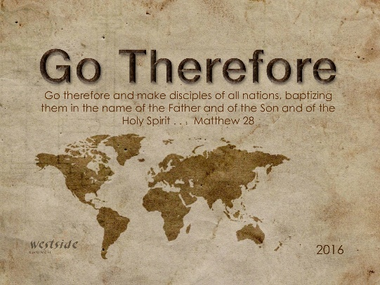

I Will Bless You

Genesis 11:31 One day Terah took his son Abram, his daughter-in-law Sarai (his son Abram’s wife), and his grandson Lot (his son Haran’s child) and moved away from Ur of the Chaldeans. He was headed for the land of Canaan, but they stopped at Haran and settled there.

Genesis 12:1-5
The LORD had said to Abram, “Leave your native country, your relatives, and your father’s family, and go to the land that I will show you. ² I will make you into a great nation. I will bless you and make you famous, and you will be a blessing to others. ³ I will bless those who bless you and curse those who treat you with contempt. (so that) All the families on earth will be blessed through you.” (a command and a promise – you will bless AND you will be a blessing) ⁴ So Abram departed as the LORD had instructed, and Lot went with him. Abram was seventy-five years old when he left Haran. ⁵ He took his wife, Sarai, his nephew Lot, and all his wealth—his livestock and all the people he had taken into his household at Haran—and headed for the land of Canaan.

Abrahamic Covenant

1. ________________ Required

Hebrews 11:1,8-10 (NLT)
¹ Faith is the confidence that what we hope for will actually happen; it gives us assurance about things we cannot see . . . ⁸ It was by faith that Abraham obeyed when God called him to leave home and go to another land that God would give him as his inheritance. He went without knowing where he was going. ⁹ And even when he reached the land God promised him, he lived there by faith—for he was like a foreigner, living in tents. And so did Isaac and Jacob, who inherited the same promise. ¹⁰ Abraham was confidently looking forward to a city with eternal foundations, a city designed and built by God.

2. __________________ Required

Faith is key.

James McDonald says:
“It’s like the person who's filled with
concerns and wants to have hope,
but has never read the Bible.”

It's God’s promises that give us hope.

Get your heart around some of the awesomely great and treasured promises of God!

3. Being A __________________ Required

Abram still was commanded to BE a blessing—it is still an imperative. This imperative is followed by three more promises. Because of the sequential construction of the clauses, the entire call of Abram follows a chain reaction, beginning with his getting out of Ur. This structure also emphasizes that his call had a purpose—to be a blessing.
-Cornerstone Biblical Commentary
Results of Abram’s Faith

1. ___________________

- “I will make you into a great nation”
- “I will bless you and make you famous”
- “I will bless those who bless you and curse those who curse you”
- “All the families on earth will be blessed through you”

2. More ____________________

Genesis 12:4-6
So Abram departed as the LORD had instructed, and Lot went with him. Abram was seventy-five years old when he left Haran. ⁵ He took his wife, Sarai, his nephew Lot, and all his wealth—his livestock and all the people he had taken into his household at Haran—and headed for the land of Canaan. When they arrived in Canaan, ⁶ Abram traveled through the land as far as Shechem. There he set up camp beside the oak of Moreh. At that time, the area was inhabited by Canaanites.

3. More ____________________

Genesis 12:7
Then the LORD appeared to Abram and said, “I will give this land to your descendants.” And Abram built an altar there and dedicated it to the LORD, who had appeared to him.

4. And _______________ Blessing

Genesis 14:16-20
Abram recovered all the goods that had been taken, and he brought back his nephew Lot with his possessions and all the women and other captives. ¹⁷ After Abram returned from his victory over Kedorlaomer and all his allies, the king of Sodom went out to meet him in the valley of Shaveh (that is, the King’s Valley). ¹⁸ And Melchizedek, the king of Salem and a priest of God Most High, brought Abram some bread and wine. ¹⁹ Melchizedek blessed Abram with this blessing: “Blessed be Abram by God Most High, Creator of heaven and earth. ²⁰ And blessed be God Most High, who has defeated your enemies for you.” Then Abram gave Melchizedek a tenth of all the goods he had recovered.

- the tithe began with Abraham the “Father of Faith”

Luke 6:38 (ESV)
“Give, and it will be given to you. Good measure, pressed down, shaken together, running over, will be put into your lap. For with the measure you use it will be measured back to you.”

Response:

What is God speaking to me?

Specifically, how will I obey Him?

